PREEZ BRANDS Full Engineering Specification (SRS)
I will create this in 8 major parts:
- Project Overview
- Functional Requirements (All Modules)
- User Roles & Permissions
- Business Rules & Workflows
- Database Schema
- UI/UX Blueprint
- Non-Functional Requirements
- Master AI-Coder Prompt
Because of the size, I will deliver it in sections.
Today we start with:
SRS Part 1 — Project Overview & System Scope

1. Project Information
System Name
Business Sales, Inventory, Debt & Accounting Management System
Alternative product name (optional branding):
- Taply Business ERP
- SalesFlow ERP
- SmartLedger ERP

2. Project Purpose
The purpose of this system is to provide a centralized web-based platform for managing:
- Sales
- Clients
- Quotations
- Invoices
- Payments
- Customer debts
- Inventory
- Product variants
- Suppliers
- Purchase orders
- Expenses
- Returns / Refunds
- Reports & analytics
- Staff management
- Notifications
- Audit logs
- Account settings
The system must help the business owner monitor daily operations in real time from any device.

3. Problem Statement
The client currently struggles with:
- Manual sales tracking
- Difficulty tracking debts
- Poor client payment visibility
- Weak inventory control
- Limited reporting
- Difficulty tracking staff activity
- Lack of centralized financial visibility
Problems caused:
- Revenue leakage
- Fraud risk
- Stock mismanagement
- Poor debt recovery
- Slow decision making
The system solves these problems.

4. Objectives
Primary objectives:
Sales Monitoring
Track all sales in real time.
Debt Monitoring
Track all customer debts and payment history.
Inventory Control
Monitor stock movement and low stock alerts.
Financial Reporting
Measure:
- Revenue
- Expenses
- Profit
- Debt collection rate
Staff Accountability
Track all user activities.

5. System Type
System classification:
- Web-based ERP
- POS-enabled sales system
- CRM-capable client system
- Accounting support system
This is effectively a:
Mini ERP + POS + CRM + Accounting Hybrid
This is important for architecture.

6. Deployment Scope
Phase 1
Single tenant deployment.
One business only.
Architecture should remain SaaS-ready.
Future SaaS migration requires:
tenant_id
subscription_plan
billing_cycle
tenant_settings

7. Target Users
Primary users:
Super Admin
System owner.
Manager
Operational manager.
Supervisor
Supervises daily operations.
Cashier
Handles sales and payments.
Optional future users:
- Accountant
- Auditor
- Branch Manager

8. Tech Stack
Backend
Laravel
Frontend
- HTML
- CSS
- JavaScript
- Bootstrap
- Blade templates
Database
MySQL
Hosting
Phase 1:
Namecheap Shared Hosting
Future:
- DigitalOcean
- AWS

9. Core Modules
Final module list:
Authentication
- Login
- Password reset
- Session management
Core Business
- Dashboard
- Clients
- Customer Ledger
- Quotations
- Invoices
- Sales
- Payments
- Debt Management
Inventory
- Products
- Product Variants
- Categories
- Services
- Suppliers
- Purchase Orders
- Stock Management
Accounting
- Expenses
- Supplier Ledger
- Refunds / Returns
- Profit Analytics
Management
- Reports
- Notifications
- Audit Logs
- Roles & Permissions
- Settings
- Backup & Restore

10. Success Metrics
System is successful if it achieves:
Operational Metrics
- Reduce manual work by 80%
- Reduce stock mismatch
- Improve debt tracking accuracy
Financial Metrics
- Faster debt collection
- Better profit visibility
- Reduced leakage/fraud
Technical Metrics
- < 3 second page load
- 99% uptime target
- Backup reliability

11. Constraints
Current constraints:
Hosting
Shared hosting limitations:
- Limited resources
- No heavy realtime features
Budget
Need MVP-first approach.
Internet Dependency
System requires internet.
Offline mode:
Future implementation.

12. Assumptions
Assumptions for engineering:
- Single branch business
- 1–20 concurrent users
- Up to 1,000 transactions/day
- Currency = UGX Uganda
- VAT supported
- Product + service sales
- Product variants required

Senior Engineer Note
This is no longer a “small system.”
This is a commercial-grade ERP foundation.
Because of that, I strongly recommend:
- modular development
- strict architecture
- proper testing
- audit-first design
SRS Part 2 — Functional Requirements (Module-by-Module)
This section defines what every module must do, including:
- Inputs
- Outputs
- User actions
- Validations
- Business rules
- Edge cases
This becomes the implementation blueprint for your AI coder.

Module 1 — Authentication & Access Control
Purpose
Control secure access to the system.

Features
- Login
- Logout
- Forgot password
- Reset password
- Session timeout
- Account lock
- Role-based access
- 2FA (optional via settings)

Inputs
Login form:
- Email / Username
- Password
- Remember me

Validations
- User must exist
- Account must be active
- Password must match
- Locked accounts cannot login

Outputs
On success:
Redirect to dashboard based on role.
Example:
- Super Admin → Full dashboard
- Cashier → Sales dashboard

Business Rules
- Password hashed
- Failed attempts tracked
- Auto logout after inactivity
- Session timeout configurable by super admin

Module 2 — Dashboard
Purpose
Provide system overview.

Dashboard Cards
Show:
- Today Sales
- Weekly Sales
- Monthly Sales
- Outstanding Debt
- Total Customers
- Low Stock Items
- Expenses
- Profit
- Pending Refunds
- Active Staff

Charts
Charts:
- Daily sales graph
- Monthly revenue graph
- Debt collection graph
- Top-selling products
- Staff performance chart

Filters
Filter dashboard by:
- Today
- Week
- Month
- Year
- Custom range

Module 3 — User / Staff Management
Purpose
Manage users and permissions.

Roles
- Super Admin
- Manager
- Supervisor
- Cashier

User Fields
Employee ID
Full Name
Phone
Email
Username
Password
Role
Status
Profile Photo

Features
- Create user
- Edit user
- Suspend user
- Deactivate user
- Reset password
- Assign permissions
- Role overrides

Business Rules
- Super Admin controls permissions
- Soft delete only
- User history retained

Module 4 — Role & Permission Management
Purpose
Custom access control.
Use RBAC.
Tables needed later:
roles
permissions
role_permissions
user_permissions

Permission Examples
- create_sale
- edit_sale
- void_sale
- approve_refund
- manage_users
- export_reports
- manage_settings

Rules
Permissions can be:
- Role based
- User override
Example:
Cashier normally cannot refund.
Super admin can grant refund permission to one cashier.

Module 5 — Client Management
Purpose
Manage customer records.

Client Fields
Client Code
Full Name
Phone
Email
Address
TIN (optional)
Business Name
Credit Limit
Status
Notes

Features
- Add client
- Edit client
- Search client
- Deactivate client
- View client profile
- View client ledger
- View invoices
- View payment history

Business Rules
- Phone can be unique
- Client code auto-generated
- Client cannot be hard deleted

Client Profile Shows
- Personal info
- Total purchases
- Total paid
- Outstanding debt
- Active invoices
- Ledger history

Module 6 — Customer Ledger
Purpose
Track money owed by each customer.
Accounting type:
Accounts Receivable

Ledger Fields
Date
Reference
Description
Debit
Credit
Balance

Logic
Invoice created
Increase receivable.
Example:
Invoice = 500k
Ledger:
Debit 500k

Payment received
Decrease receivable.
Example:
Payment = 200k
Ledger:
Credit 200k

Balance:
Balance = Debit - Credit

Status Colors
- 🟢 Paid
- 🟠 Partial
- 🔴 Unpaid

Module 7 — Categories
Purpose
Organize products/services.

Types
- Product categories
- Service categories
Examples:
- Electronics
- Clothing
- Repair
- Printing

Features
- Add category
- Edit category
- Deactivate category

Module 8 — Products
Purpose
Manage sellable inventory.

Product Fields
Product Code
Product Name
Category
Brand
Description
Base Unit
Tax Type
Status

Features
- Add product
- Edit product
- Archive product
- Barcode support
- Product image
- Product search

Business Rules
- Product code unique
- Soft delete only

Module 9 — Product Variants
Critical module.

Purpose
Manage variant stock separately.
Example:
T-Shirt:
- Small
- Medium
- Large

Variant Fields
SKU
Barcode
Variant Name
Buying Price
Selling Price
Stock Qty
Reorder Level

Features
- Add variant
- Edit variant
- Stock adjustment
- Low stock alerts

Business Rules
Stock belongs here, not products.

Module 10 — Services
Purpose
Manage services sold.
Examples:
- Repair
- Installation
- Consultation

Fields
Service Code
Service Name
Category
Default Price
Status

Rules
Service price may be:
- Default
OR
- Custom per invoice
As confirmed by client:
Custom price allowed

Module 11 — Suppliers
Purpose
Manage suppliers.

Fields
Supplier Code
Company Name
Contact Person
Phone
Email
Address
TIN
Status

Features
- Add supplier
- Edit supplier
- Supplier profile
- Supplier ledger

Module 12 — Purchase Orders
Purpose
Order stock from suppliers.

PO Fields
PO Number
Supplier
Order Date
Expected Delivery
Total
Status
Notes

Status
- Draft
- Ordered
- Partial Received
- Received
- Cancelled

Features
- Create PO
- Approve PO
- Receive stock
- Partial receiving

Business Rules
Receiving stock updates inventory.

Module 13 — Supplier Ledger
Accounting type:
Accounts Payable
Tracks money business owes suppliers.

Ledger Logic
Purchase stock:
Debit payable
Pay supplier:
Credit payable

Fields
Date
Reference
Debit
Credit
Balance

Module 14 — Quotations
Purpose
Issue price quotations before invoice.

Fields
Quotation Number
Client
Date
Expiry Date
Subtotal
Tax
Discount
Final Amount
Status

Status
- Draft
- Sent
- Approved
- Rejected
- Expired
- Converted

Features
- Create quotation
- Print quotation
- Convert to invoice
- PDF export

Business Rules
- Cannot edit after sending
- Convert to invoice in one click
- Locked after conversion

Module 15 — Invoices
Purpose
Official billing document.

Fields
Invoice Number
Client
Date
Due Date
Subtotal
Tax
Discount
Total
Paid
Balance
Status

Status
- Draft
- Unpaid
- Partial
- Paid
- Overdue
- Cancelled
- Voided

Rules
Invoice may contain:
- Multiple products
- Multiple services
- Mixed line items

Module 16 — Sales
Purpose
Record completed sales.

Workflow
Sale process:
Create invoice
→ receive payment
→ finalize sale
→ update stock
→ create ledger entries
→ create debt if needed

Features
- Create sale
- View sale
- Print receipt
- Void sale
- Refund sale

Business Rules
Cashier:
- Create only
- Cannot edit finalized sale

Module 17 — Payments
Purpose
Track incoming payments.

Payment Types
- Cash
- Bank transfer
- Mobile Money
- Cheque
- Other

Fields
Payment Number
Invoice
Client
Amount
Payment Method
Reference
Date
Recorded By
Notes

Rules
- Full payment allowed
- Partial payment allowed
- Multiple installments allowed
- Overpayment not allowed

Allocation Rules
Admin settings choose:
- Oldest invoice first
OR
- Manual allocation
OR
- Automatic split

Module 18 — Debt Management
Purpose
Track unpaid invoices.

Fields
Debt ID
Client
Invoice
Due Date
Outstanding Balance
Status
Days Overdue

Features
- View all debts
- Filter overdue
- Partial payment
- Debt forgiveness
- Debt waiver

Rules
- No interest
- Admin can waive debt
- Every change logged

Module 19 — Expenses
Purpose
Track business expenses.

Expense Categories
- Rent
- Salary
- Fuel
- Electricity
- Internet
- Tax
- Purchases
- Misc

Fields
Expense ID
Category
Amount
Date
Description
Receipt
Created By
Approved By
Status

Status
- Pending
- Approved
- Rejected

Workflow
Staff submits expense
→ Manager approves
→ Expense posted

Module 20 — Returns / Refunds
Critical accounting module.

Types
- Product return
- Service refund
- Invoice reversal
- Credit note

Fields
Refund ID
Invoice
Client
Amount
Reason
Refund Type
Status

Rules
Product return:
- Reverse stock
- Reverse VAT
- Adjust ledger

Module 21 — Reports & Analytics
Reports include:

Sales Reports
- Daily
- Weekly
- Monthly
- Yearly

Inventory Reports
- Stock valuation
- Low stock
- Fast moving
- Dead stock

Financial Reports
- Revenue
- Expenses
- Profit
- Debt aging

Staff Reports
- Best salesperson
- Sales by user
- Refund approvals

Module 22 — Notifications
Channels
- In-app
- SMS
- Email
- WhatsApp Business

Triggers
- Low stock
- Overdue debt
- Payment received
- Refund request
- Login alert

Module 23 — Audit Logs
Track everything.

Events
- Login
- Logout
- Sale creation
- Payment edit
- Refund approval
- Expense approval
- Settings change

Fields
User
Action
Entity
Old Value
New Value
Timestamp
IP Address

Module 24 — Settings
System configuration.

Settings Sections
- Business profile
- Logo
- Tax settings
- Currency
- Security
- Invoice settings
- Payment allocation rules
- Notification rules

Module 25 — Backup & Restore
Features
- Daily backup
- Manual backup
- Restore backup
- Download backup

Backup Scope
- Database
- Receipts
- PDFs
- Logs

Senior Engineer Review of Part 2
You now have complete functional scope.
This SRS Part 2 defines what the system does.

SRS Part 3 — User Roles, Permission Matrix & Detailed Business Workflows
This section defines:
- Who can do what
- Who approves what
- How transactions move through the system
- Fraud prevention rules
- Approval chains
- Edge case handling
This is critical because financial systems fail when workflows are vague.

1. User Roles Architecture
The system will use RBAC (Role-Based Access Control).
Primary roles:
- Super Admin
- Manager
- Supervisor
- Cashier
Future optional roles:
- Accountant
- Auditor
- Branch Manager

2. Role Definitions

Super Admin
Highest authority.
Full unrestricted access.
Responsibilities:
- System ownership
- Security configuration
- Role permission assignment
- Financial oversight
- Backup management
- Restore operations
- Audit review
- Billing/SaaS management (future)
Can access all modules.

Manager
Business operations manager.
Responsibilities:
- Manage daily operations
- Inventory oversight
- Financial approval
- Supplier management
- Debt management
- Expense approval
Has broad access but cannot override system ownership settings.

Supervisor
Mid-level operational controller.
Responsibilities:
- Monitor cashier activities
- Monitor stock
- Approve limited actions
- Handle escalations
Limited authority.

Cashier
Frontline sales role.
Responsibilities:
- Sales
- Invoicing
- Customer registration
- Payment collection
- Receipt printing
Restricted from sensitive operations.

3. Permission Matrix
Legend:
✅ Allowed
⚠ Limited / Configurable
❌ Not Allowed
Permission | Cashier | Supervisor | Manager | Super Admin
Login | ✅ | ✅ | ✅ | ✅
Dashboard | ✅ | ✅ | ✅ | ✅
Create Sale | ✅ | ✅ | ✅ | ✅
Edit Finalized Sale | ❌ | ❌ | ⚠ | ✅
Void Sale | ❌ | ⚠ | ✅ | ✅
Create Client | ✅ | ✅ | ✅ | ✅
Edit Client | ⚠ | ✅ | ✅ | ✅
Create Quotation | ✅ | ✅ | ✅ | ✅
Convert Quotation | ⚠ | ✅ | ✅ | ✅
Create Invoice | ✅ | ✅ | ✅ | ✅
Receive Payment | ✅ | ✅ | ✅ | ✅
Edit Payment | ❌ | ⚠ | ✅ | ✅
Waive Debt | ❌ | ❌ | ⚠ | ✅
Refund Sale | ❌ | ⚠ | ✅ | ✅
Add Product | ❌ | ⚠ | ✅ | ✅
Edit Product | ❌ | ⚠ | ✅ | ✅
Stock Adjustment | ❌ | ⚠ | ✅ | ✅
Purchase Orders | ❌ | ⚠ | ✅ | ✅
Add Expense | ⚠ | ⚠ | ✅ | ✅
Approve Expense | ❌ | ❌ | ✅ | ✅
Reports Export | ❌ | ⚠ | ✅ | ✅
Manage Staff | ❌ | ❌ | ⚠ | ✅
Settings | ❌ | ❌ | ⚠ | ✅
Backups | ❌ | ❌ | ❌ | ✅
Restore Backup | ❌ | ❌ | ❌ | ✅

4. Permission Override Rules
Super Admin can customize permissions.
Example:
Cashier normally cannot refund.
But Super Admin may grant:
approve_refund = true
for one cashier.
This requires tables:
roles
permissions
role_permissions
user_permissions
Permission priority:
User Permission Override
> Role Permission
Meaning:
Custom user permission overrides role default.

5. Business Workflow — Sales Lifecycle
Main workflow:
Client identified
→ quotation (optional)
→ invoice created
→ payment received
→ sale finalized
→ stock updated
→ ledger updated
→ debt created if unpaid

Step 1 — Client Selection
Cashier selects:
Option A:
Existing client
OR
Option B:
New client registration
Rules:
- Walk-in customers allowed
- Registered clients preferred for debt tracking

Step 2 — Quotation (Optional)
If client requests quote:
Cashier creates quotation.
Status:
- Draft
- Sent
- Approved
- Rejected
- Expired
Rules:
- Cannot edit after sending
- Can convert to invoice

Step 3 — Invoice Creation
Invoice can include:
- Multiple products
- Multiple variants
- Multiple services
Example:
Item | Qty | Price
T-Shirt (Large) | 2 | 50k
Repair Service | 1 | 100k
System calculates:
Subtotal
+ VAT
- Discount
= Final Total

6. Payment Workflow
Payment types:
- Cash
- Mobile Money
- Bank Transfer
- Cheque
- Other

Payment Scenarios

Scenario A — Full Payment
Invoice total = 500k
Client pays = 500k
Result:
- Invoice status = Paid
- Sale status = Completed
- Ledger updated
Color:
🟢 Green

Scenario B — Partial Payment
Invoice total = 500k
Paid = 200k
Balance = 300k
Result:
- Debt created
- Ledger updated
Color:
🟠 Orange

Scenario C — No Payment
Invoice total = 500k
Paid = 0
Result:
- Full debt created
Color:
🔴 Red

Validation Rules
- Negative payment forbidden
- Overpayment forbidden
- Payment edits logged
- Payment deletion forbidden (void only)

7. Debt Management Workflow
Debt starts when:
Invoice balance > 0

Debt Rules
- No automatic interest
- Due date optional / invoice-based
- Debt can be partially paid
- Debt can be waived by authorized users

Debt Aging
System calculates:
- Current
- 1–30 days overdue
- 31–60 days overdue
- 61–90 days overdue
- 90+ overdue
Useful for collection.

8. Customer Payment Allocation Workflow
Customer may pay multiple invoices at once.
Example:
Invoice A → 300k
Invoice B → 700k
Payment → 500k
Allocation modes:

Mode 1 — FIFO (Default)
Oldest invoice first.
Result:
Invoice A paid fully
Invoice B partial

Mode 2 — Manual Allocation
Manager manually chooses invoice allocation.

Mode 3 — Auto Split
System distributes based on rule.
Configurable in settings.

9. Inventory Workflow
Stock movement sources:
- Sales
- Purchases
- Returns
- Manual adjustments
- Damages

Sale
When sale finalized:
Stock = Stock - Sold Qty

Purchase
When stock received:
Stock = Stock + Received Qty

Return
Returned product:
Stock = Stock + Returned Qty

Damaged Goods
Manual adjustment:
Stock = Stock - Damaged Qty
All stock changes logged.

10. Purchase Order Workflow
Workflow:
Create PO
→ approval
→ supplier fulfillment
→ receive stock
→ supplier ledger update
Statuses:
- Draft
- Approved
- Ordered
- Partial Received
- Received
- Cancelled

11. Expense Approval Workflow
Because staff can submit expenses, approval is mandatory.
Workflow:
Staff creates expense
→ Pending
→ Manager reviews
→ Approved / Rejected

Rules
Pending expense:
- Does NOT affect financial reports
Approved expense:
- Included in reports
Rejected:
- Logged only

12. Refund Workflow
Refund triggers:
- Product return
- Service cancellation
- Wrong invoice
- Billing error

Refund Process
Workflow:
Refund request
→ supervisor review
→ manager approval
→ refund execution
→ stock/ledger adjustment

Product Refund
Actions:
- Reverse sale quantity
- Increase stock
- Reverse VAT
- Update ledger

Service Refund
Actions:
- Reverse revenue
- Refund client
- Update ledger

13. Financial Calculation Rules
Critical formulas.

Invoice Total
Subtotal = Sum(Line Items)
Tax = VAT%
Final = Subtotal + Tax - Discount

Outstanding Balance
Balance = Invoice Total - Payments

Profit
Profit = Revenue - Expenses - Cost of Goods Sold

Stock Valuation
Stock Value = Qty × Buying Price

14. Audit Logging Rules
Every sensitive action logged.
Must log:
- Login
- Logout
- Sale creation
- Sale void
- Payment edits
- Refund approvals
- Expense approvals
- Settings changes
- Permission changes
- Backup restore
Log format:
User
Action
Old Value
New Value
Timestamp
IP Address
Device

15. Fraud Prevention Rules
Critical for finance.
System rules:

Rule 1
No hard delete for financial records.
Only:
- Void
- Cancel
- Soft delete

Rule 2
Edits require authorization.
Example:
Cashier cannot edit finalized sale.

Rule 3
Critical actions require approval.
Examples:
- Refunds
- Debt waivers
- Expense approvals

Rule 4
Everything auditable.
Nothing should disappear silently.

16. Security Workflow
Authentication rules:
- Strong passwords
- Session timeout
- Role authorization
- Password hashing
- Optional 2FA
- IP restrictions (optional)
Sensitive actions may require re-authentication.
Example:
Before restore backup:
Enter password again

Senior Engineer Assessment — Part 3
This section now defines:
✅ Exact user authority
✅ Approval hierarchy
✅ Operational workflows
✅ Fraud prevention
✅ Financial rules
This is the business logic brain of the entire system.

SRS Part 4 — Complete Database Schema & Table Relationships
This section defines:
- Database architecture
- Tables
- Columns
- Primary keys
- Foreign keys
- Indexes
- Relationships
- Normalization strategy
This schema is designed for:
- Laravel migrations
- MySQL (InnoDB)
- Single-tenant Phase 1
- SaaS-ready Phase 2

1. Database Design Principles
We follow:
Normalization
- Minimum 3NF
- Avoid duplicate data
- Separate transaction tables

Primary Key Standard
Use:
BIGINT UNSIGNED AUTO_INCREMENT
for all IDs.
Example:
id BIGINT PRIMARY KEY

Timestamp Standard
Almost all tables include:
created_at
updated_at
deleted_at
Use soft deletes for sensitive records.

Future SaaS Readiness
Optional future column:
tenant_id
Can be added later to business tables.

2. Core Relationship Overview
High-level relationships:
Users -> Sales
Users -> Payments
Users -> Expenses
Clients -> Quotations
Clients -> Invoices
Clients -> Payments
Clients -> Customer Ledger
Products -> Variants
Products -> Categories
Suppliers -> Purchase Orders
Suppliers -> Supplier Ledger
Invoices -> Invoice Items
Invoices -> Payments
Invoices -> Debts
Invoices -> Refunds

3. Authentication Tables

users
Stores staff accounts.
Column | Type
id | BIGINT
employee_code | VARCHAR
full_name | VARCHAR
phone | VARCHAR
email | VARCHAR
username | VARCHAR
password | VARCHAR
role_id | BIGINT
profile_photo | VARCHAR
status | ENUM
last_login_at | DATETIME
created_at | TIMESTAMP
updated_at | TIMESTAMP
deleted_at | TIMESTAMP
Indexes:
- email unique
- username unique
- employee_code unique

roles
Column | Type
id | BIGINT
name | VARCHAR
description | TEXT
Examples:
- Super Admin
- Manager
- Supervisor
- Cashier

permissions
Column | Type
id | BIGINT
code | VARCHAR
name | VARCHAR
Examples:
- create_sale
- approve_refund

role_permissions
Pivot table.
Column | Type
id | BIGINT
role_id | BIGINT
permission_id | BIGINT

user_permissions
Overrides.
Column | Type
id | BIGINT
user_id | BIGINT
permission_id | BIGINT
allowed | BOOLEAN

4. Client Tables

clients
Column | Type
id | BIGINT
client_code | VARCHAR
full_name | VARCHAR
phone | VARCHAR
email | VARCHAR
address | TEXT
business_name | VARCHAR
tin_number | VARCHAR
credit_limit | DECIMAL
notes | TEXT
status | ENUM
Indexes:
- client_code unique
- phone index

customer_ledgers
Tracks receivables.
Column | Type
id | BIGINT
client_id | BIGINT
reference_type | VARCHAR
reference_id | BIGINT
entry_date | DATE
description | TEXT
debit | DECIMAL
credit | DECIMAL
balance | DECIMAL
Examples:
- Invoice
- Payment
- Refund
- Waiver

5. Product Tables

categories
Column | Type
id | BIGINT
name | VARCHAR
type | ENUM(product/service)
status | ENUM

brands
Optional.
Column | Type
id | BIGINT
name | VARCHAR

products
Master product table.
Column | Type
id | BIGINT
product_code | VARCHAR
category_id | BIGINT
brand_id | BIGINT
product_name | VARCHAR
description | TEXT
base_unit | VARCHAR
tax_type | VARCHAR
status | ENUM

product_variants
Critical stock table.
Column | Type
id | BIGINT
product_id | BIGINT
sku | VARCHAR
barcode | VARCHAR
variant_name | VARCHAR
buying_price | DECIMAL
selling_price | DECIMAL
stock_qty | DECIMAL
reorder_level | DECIMAL
status | ENUM
Indexes:
- sku unique
- barcode unique

stock_movements
Audit stock changes.
Column | Type
id | BIGINT
variant_id | BIGINT
movement_type | ENUM
quantity | DECIMAL
reference_type | VARCHAR
reference_id | BIGINT
notes | TEXT
created_by | BIGINT
Movement types:
- sale
- purchase
- return
- adjustment
- damage

6. Service Tables

services
Column | Type
id | BIGINT
service_code | VARCHAR
category_id | BIGINT
service_name | VARCHAR
default_price | DECIMAL
description | TEXT
status | ENUM

7. Supplier Tables

suppliers
Column | Type
id | BIGINT
supplier_code | VARCHAR
company_name | VARCHAR
contact_person | VARCHAR
phone | VARCHAR
email | VARCHAR
address | TEXT
tin_number | VARCHAR
status | ENUM

supplier_ledgers
Accounts payable.
Column | Type
id | BIGINT
supplier_id | BIGINT
reference_type | VARCHAR
reference_id | BIGINT
debit | DECIMAL
credit | DECIMAL
balance | DECIMAL
description | TEXT

8. Purchase Tables

purchase_orders
Column | Type
id | BIGINT
po_number | VARCHAR
supplier_id | BIGINT
order_date | DATE
expected_delivery | DATE
subtotal | DECIMAL
tax | DECIMAL
total | DECIMAL
status | ENUM
notes | TEXT
created_by | BIGINT
Statuses:
- draft
- approved
- ordered
- partial_received
- received
- cancelled

purchase_order_items
Column | Type
id | BIGINT
purchase_order_id | BIGINT
variant_id | BIGINT
quantity | DECIMAL
unit_price | DECIMAL
total | DECIMAL

9. Sales Tables

quotations
Column | Type
id | BIGINT
quotation_number | VARCHAR
client_id | BIGINT
quote_date | DATE
expiry_date | DATE
subtotal | DECIMAL
tax | DECIMAL
discount | DECIMAL
total | DECIMAL
status | ENUM
created_by | BIGINT
Statuses:
- draft
- sent
- approved
- rejected
- expired
- converted

quotation_items
Column | Type
id | BIGINT
quotation_id | BIGINT
item_type | ENUM
item_id | BIGINT
description | TEXT
quantity | DECIMAL
unit_price | DECIMAL
total | DECIMAL
item_type:
- product_variant
- service

invoices
Core billing table.
Column | Type
id | BIGINT
invoice_number | VARCHAR
client_id | BIGINT
quotation_id | BIGINT nullable
invoice_date | DATE
due_date | DATE
subtotal | DECIMAL
tax | DECIMAL
discount | DECIMAL
total | DECIMAL
paid_amount | DECIMAL
balance | DECIMAL
status | ENUM
created_by | BIGINT
Statuses:
- draft
- unpaid
- partial
- paid
- overdue
- cancelled
- voided

invoice_items
Column | Type
id | BIGINT
invoice_id | BIGINT
item_type | ENUM
item_id | BIGINT
description | TEXT
quantity | DECIMAL
unit_price | DECIMAL
total | DECIMAL

sales
Represents finalized sales.
Column | Type
id | BIGINT
sale_number | VARCHAR
invoice_id | BIGINT
client_id | BIGINT
total | DECIMAL
sale_date | DATETIME
status | ENUM
created_by | BIGINT

10. Payment Tables

payments
Column | Type
id | BIGINT
payment_number | VARCHAR
invoice_id | BIGINT
client_id | BIGINT
amount | DECIMAL
payment_method | ENUM
payment_reference | VARCHAR
payment_date | DATETIME
notes | TEXT
recorded_by | BIGINT
status | ENUM
Methods:
- cash
- bank
- mobile_money
- cheque
- other

payment_allocations
For multi-invoice allocation.
Column | Type
id | BIGINT
payment_id | BIGINT
invoice_id | BIGINT
allocated_amount | DECIMAL
This supports:
- FIFO
- manual allocation
- split allocation

11. Debt Tables

debts
Column | Type
id | BIGINT
debt_number | VARCHAR
client_id | BIGINT
invoice_id | BIGINT
due_date | DATE
outstanding_balance | DECIMAL
waived_amount | DECIMAL
status | ENUM
Statuses:
- unpaid
- partial
- paid
- waived

debt_waivers
Column | Type
id | BIGINT
debt_id | BIGINT
amount | DECIMAL
reason | TEXT
approved_by | BIGINT

12. Expense Tables

expense_categories
Column | Type
id | BIGINT
name | VARCHAR

expenses
Column | Type
id | BIGINT
expense_category_id | BIGINT
amount | DECIMAL
expense_date | DATE
description | TEXT
receipt_file | VARCHAR
created_by | BIGINT
approved_by | BIGINT
status | ENUM
Statuses:
- pending
- approved
- rejected

13. Refund Tables

refunds
Column | Type
id | BIGINT
refund_number | VARCHAR
invoice_id | BIGINT
client_id | BIGINT
amount | DECIMAL
refund_type | ENUM
reason | TEXT
approved_by | BIGINT
status | ENUM
Types:
- product_return
- service_refund
- invoice_reversal
- credit_note

refund_items
Column | Type
id | BIGINT
refund_id | BIGINT
invoice_item_id | BIGINT
quantity | DECIMAL
amount | DECIMAL

14. Reporting Support Tables

audit_logs
Column | Type
id | BIGINT
user_id | BIGINT
action | VARCHAR
entity_type | VARCHAR
entity_id | BIGINT
old_values | JSON
new_values | JSON
ip_address | VARCHAR
user_agent | TEXT
created_at | TIMESTAMP

notifications
Column | Type
id | BIGINT
user_id | BIGINT
title | VARCHAR
message | TEXT
channel | ENUM
is_read | BOOLEAN
Channels:
- app
- sms
- email
- whatsapp

backups
Track backups.
Column | Type
id | BIGINT
backup_name | VARCHAR
backup_path | VARCHAR
file_size | BIGINT
created_by | BIGINT
created_at | TIMESTAMP

15. Settings Tables

settings
Simple key-value storage.
Column | Type
id | BIGINT
key | VARCHAR
value | LONGTEXT
Examples:
business_name
currency
vat_rate
invoice_prefix
session_timeout
payment_allocation_mode

16. Foreign Key Relationships
Major relationships:
roles 1---many users
clients 1---many invoices
clients 1---many payments
products 1---many variants
suppliers 1---many purchase_orders
invoices 1---many invoice_items
invoices 1---many payments
invoices 1---1 debts
refunds 1---many refund_items

17. Recommended Indexes
Important for performance.
Index these heavily:
invoice_number
quotation_number
client_id
supplier_id
payment_date
sale_date
status
sku
barcode
Composite indexes:
(client_id, status)
(invoice_id, status)
(product_id, status)

18. Database Strategy for Laravel
Recommended architecture:
Models:
User
Role
Client
Invoice
Payment
Product
Variant
Supplier
Expense
Refund
Relationships:
Example:
Client hasMany Invoice
Invoice belongsTo Client
Invoice hasMany Payment
Product hasMany Variant
Use:
- Eloquent ORM
- Migrations
- Seeders
- Factories
- Transactions

Senior Engineer Review — Part 4
This schema provides:
✅ Complete relational architecture
✅ Financial data integrity
✅ Audit capability
✅ Inventory traceability
✅ SaaS migration readiness
This is production-grade database design for a Laravel ERP system.

SRS Part 5 — UI/UX Blueprint & Page-by-Page Screen Design
This section defines:
- UI architecture
- Navigation layout
- Page hierarchy
- Tables & forms
- Components
- Mobile behavior
- UX interactions
- Bootstrap design system
Goal:
Build a clean ERP dashboard UI that works well on:
- Desktop
- Tablet
- Mobile
Since your users include:
- Cashiers (speed matters)
- Managers (reports matter)
- Super Admin (control matters)
The UI must optimize for speed + clarity + low training time.

1. Design Principles
UI philosophy:
Simple
Avoid clutter.
Fast
Critical actions ≤ 3 clicks.
Consistent
Same UI patterns everywhere.
Financial Clarity
Important values highly visible.
Example:
- Debt → colored badge
- Profit → highlighted card
- Refund → warning color

2. Design System
Frontend stack:
- HTML
- CSS
- JavaScript
- Bootstrap
- Bootstrap Icons
Recommended admin template inspiration (not mandatory):
- AdminLTE
- Tabler

3. Color System
Use financial status colors consistently.
Primary
Blue
Buttons / navigation
Success
Green
Paid / positive metrics
Warning
Orange
Partial payment / caution
Danger
Red
Debt / overdue / refund alerts
Neutral
Gray
Secondary info
Debt status legend:
- 🟢 Paid
- 🟠 Partial
- 🔴 Unpaid

4. Typography
Recommended:
- Font: Inter / Roboto / System UI
- Heading weight: 600–700
- Body weight: 400–500
Sizes:
- Page title: 24–28px
- Card metric: 20–32px
- Body: 14–16px

5. Main Layout Structure
Desktop layout:
+---------------------------------------------------------+
| Top Navbar |
+-------------+-------------------------------------------+
| Sidebar | Main Content |
| Navigation | |
| | Dashboard / Tables / Forms / Reports |
| | |
+-------------+-------------------------------------------+

6. Top Navbar
Contains:
Left:
- Hamburger (collapse sidebar)
Center:
- Search bar
Right:
- Notifications bell
- Messages
- User avatar dropdown
User dropdown:
- Profile
- Settings
- Logout

7. Sidebar Navigation
Core navigation:
Dashboard
Sales
├── New Sale
├── Sales History
Clients
├── All Clients
├── Customer Ledger
Quotations
Invoices
Payments
Debt Management
Inventory
├── Products
├── Variants
├── Categories
├── Stock Movement
Services
Suppliers
Purchase Orders
Expenses
Refunds
Reports
Staff
Audit Logs
Settings
Backup
Role-based visibility applies.
Cashier sees fewer menus.

8. Login Page
Minimal professional design.
Layout:
+-------------------------------+
| Company Logo |
| Business Name |
|-------------------------------|
| Username / Email |
| Password |
| Remember Me |
| Login Button |
| Forgot Password |
+-------------------------------+
Features:
- Password show/hide
- Validation errors
- Optional dark mode later
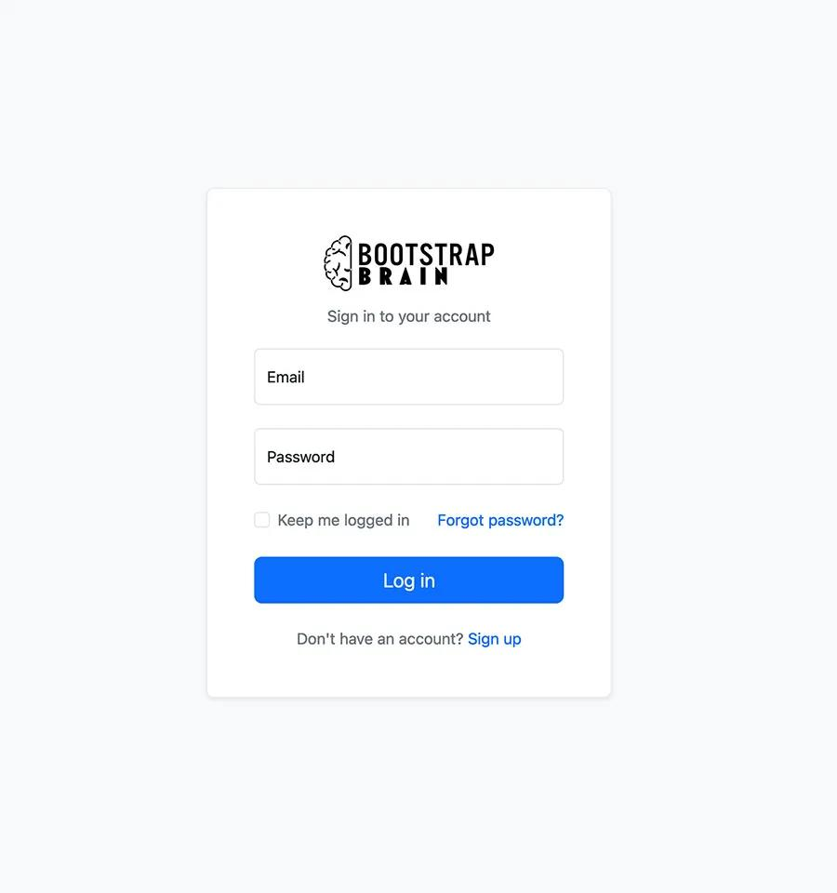
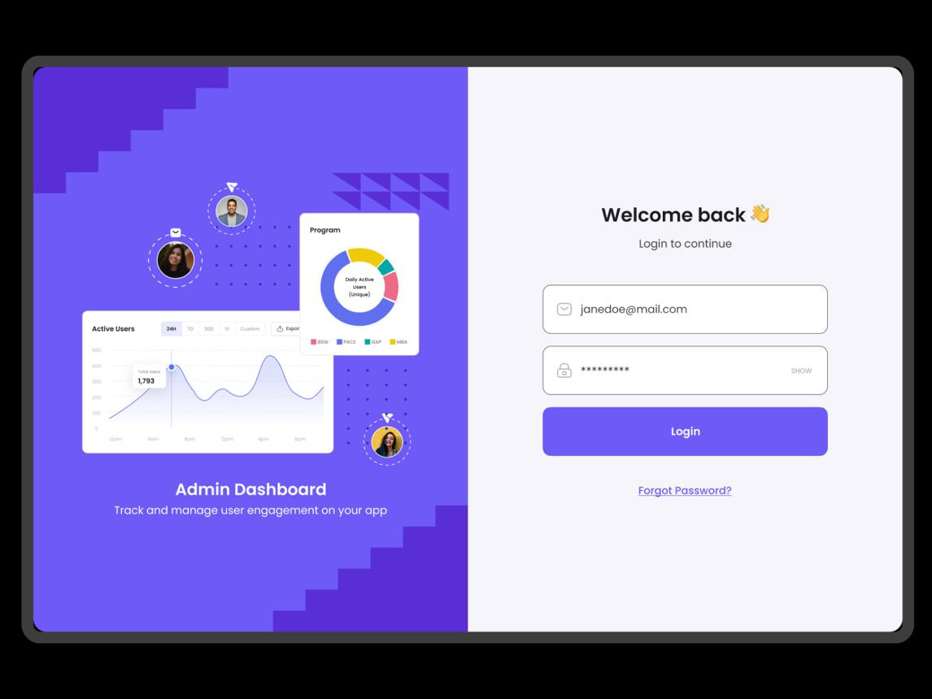
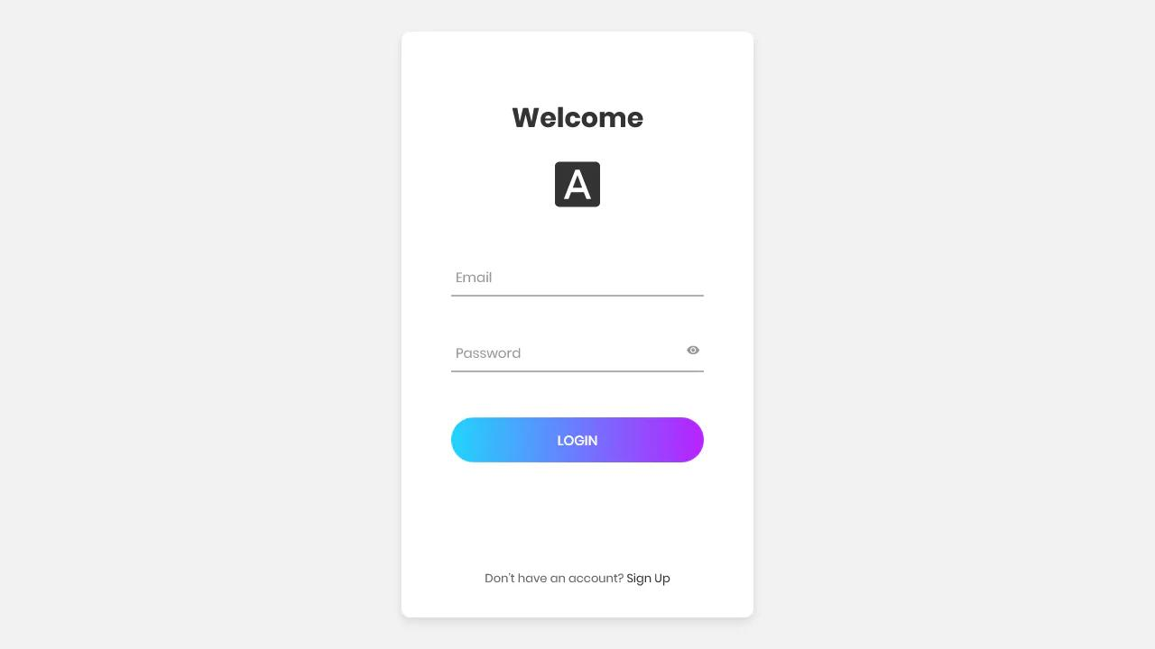
5

9. Dashboard Screen
Most important page.

KPI Cards Row
Show:
Today Sales
Monthly Revenue
Outstanding Debt
Profit
Expenses
Low Stock
Refund Requests
Active Staff
Card example:
+--------------------+
| Today Sales |
| UGX 4,250,000 |
| +12% from yesterday|
+--------------------+

Charts Section
Use charts for:
Revenue Trend
Line chart
Sales by Category
Bar chart
Debt Collection
Donut chart
Top Products
Bar chart
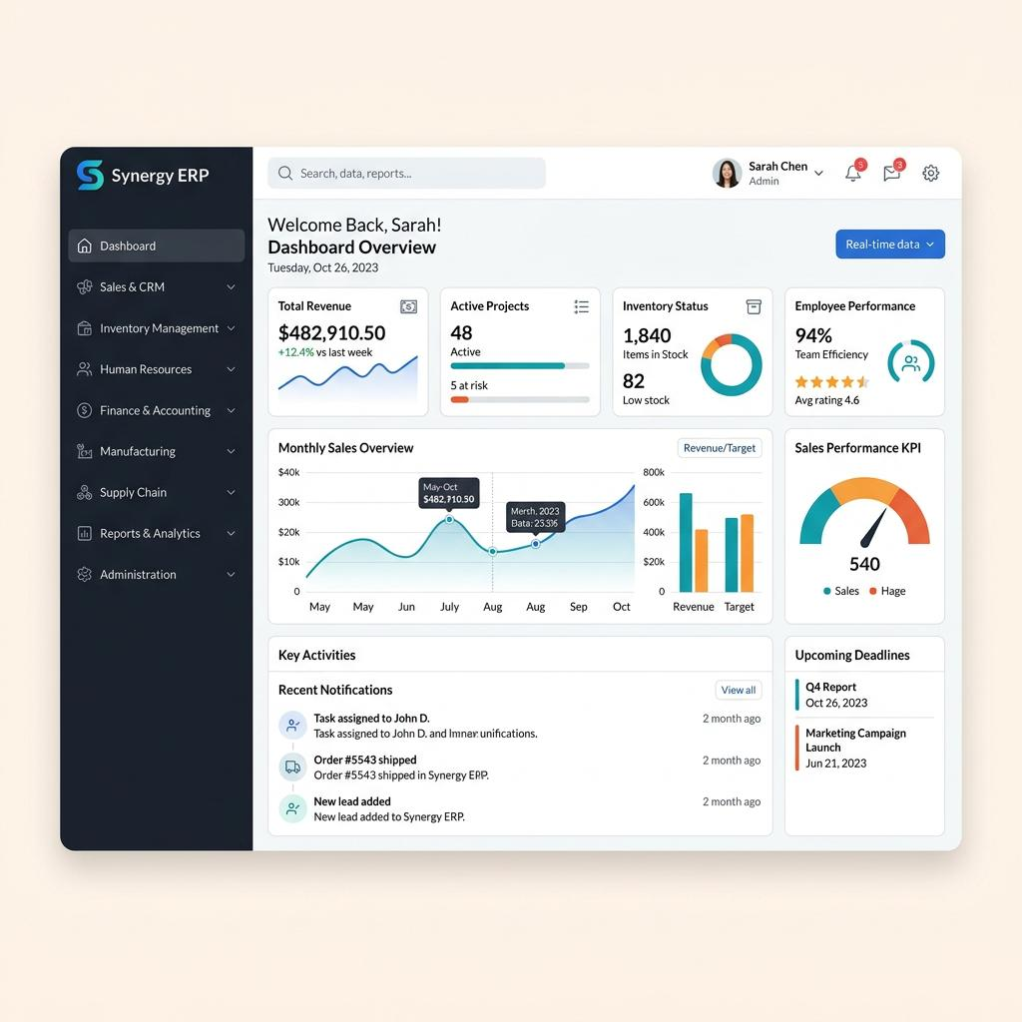
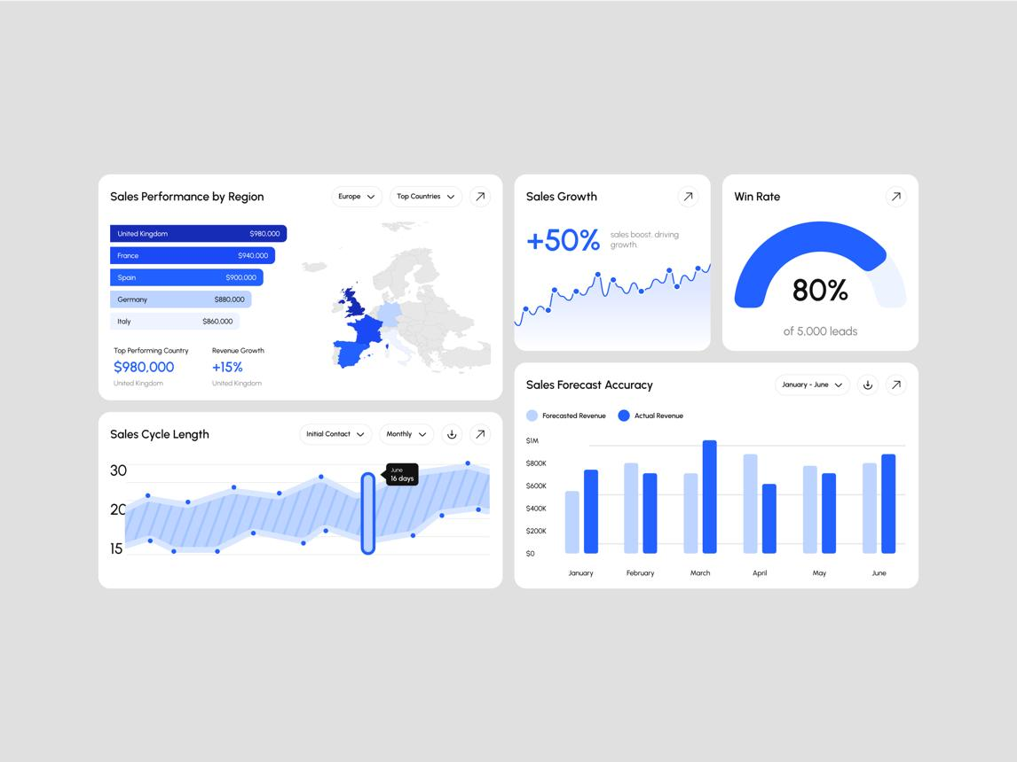
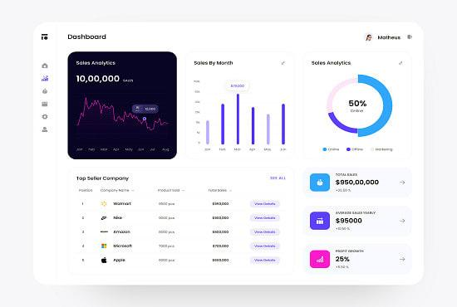
6

Activity Feed
Right panel:
Recent actions:
10:02 John created sale #1001
10:08 Mary approved refund #22
10:20 Peter added expense

10. Generic Table Page Layout
Used by:
- Clients
- Products
- Sales
- Invoices
- Payments
Layout:
Page Title
Filters Row
Search
Export
Add New Button
Table
Pagination

Table Features
Required:
- Search
- Sort
- Pagination
- Export CSV/PDF
- Bulk actions
- Column hide/show
- Date filters
Example table:
Invoice | Client | Total | Paid | Balance | Status | Action
Action dropdown:
- View
- Edit
- Print
- Void

11. Client Pages
Client List Page
Columns:
- Client code
- Name
- Phone
- Total purchases
- Outstanding balance
- Status
- Actions

Client Profile Page
Layout:
Left:
Profile card
Right:
Tabs
Tabs:
- Overview
- Ledger
- Invoices
- Payments
- Notes
Profile card:
Client Name
Phone
Email
Credit Limit
Outstanding Debt
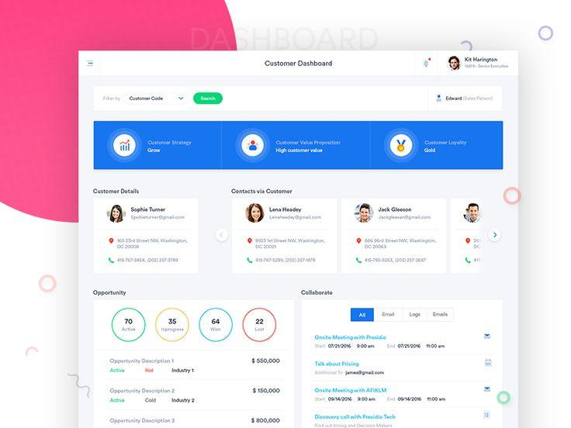
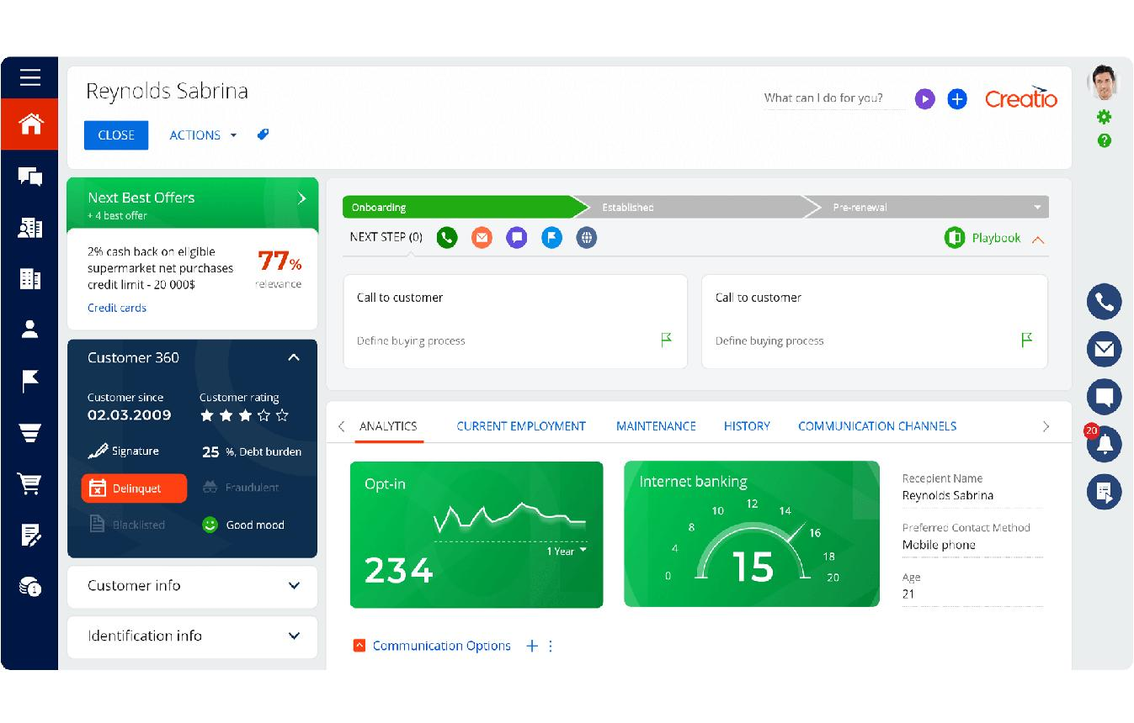

12. Sales Screen (POS Style)
This page must prioritize speed.
Layout:
Left:
Product selection
Right:
Cart / invoice summary

Product Search
Search by:
- Name
- SKU
- Barcode
Optional:
Barcode scanner support.

Cart Panel
Shows:
| Item | Qty | Price | Total |
Bottom:
Subtotal
VAT
Discount
Grand Total
Amount Paid
Balance
Buttons:
- Save Draft
- Complete Sale
- Print Receipt
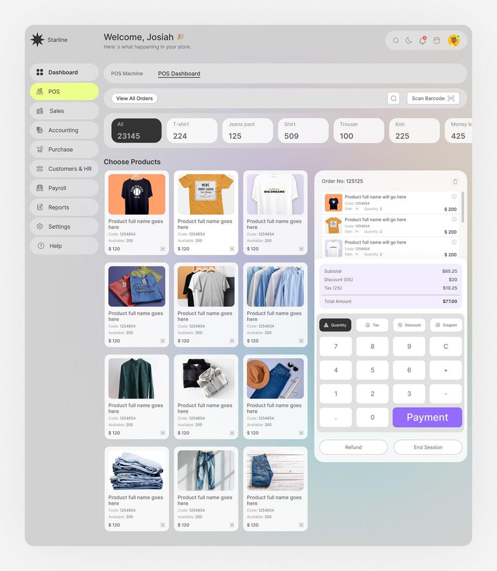
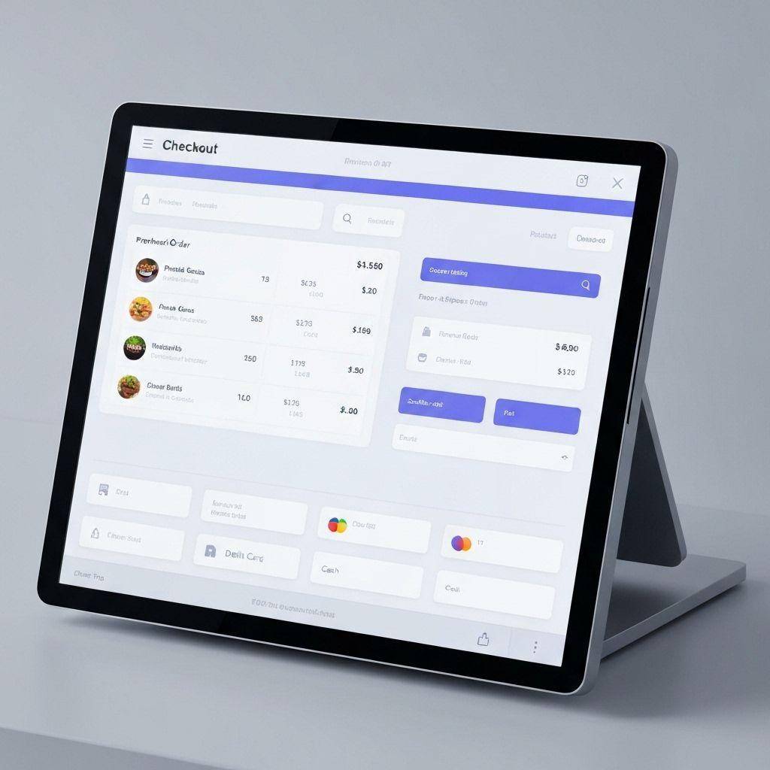
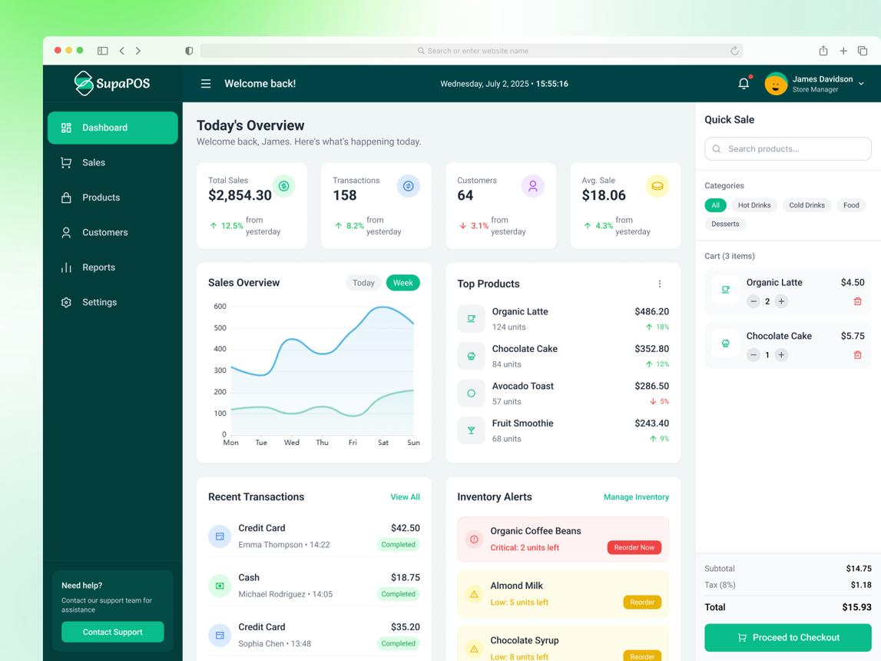
6

13. Invoice Screen
Invoice details page:
Header:
- Invoice number
- Client
- Date
- Due date
- Status badge
Body:
Line items
Footer:
Totals
Actions:
- Print
- Download PDF
- Send Email
- Send WhatsApp

14. Quotation Screen
Similar to invoice.
Differences:
Status badges:
- Draft
- Sent
- Approved
- Rejected
- Expired
- Converted
CTA button:
Convert to Invoice
Large visible button.

15. Payment Screen
Payment form:
Fields:
- Client
- Invoice(s)
- Amount
- Method
- Reference
- Notes

Allocation UI
If multiple invoices:
Show allocation table.
Invoice | Outstanding | Allocate
Useful for:
- FIFO
- Manual allocation

16. Debt Management Page
Critical financial page.
Filters:
- All
- Paid
- Partial
- Unpaid
- Overdue
Table:
| Client | Invoice | Due Date | Balance | Days Overdue | Status |
Color-coded badges mandatory.
Overdue rows highlighted.
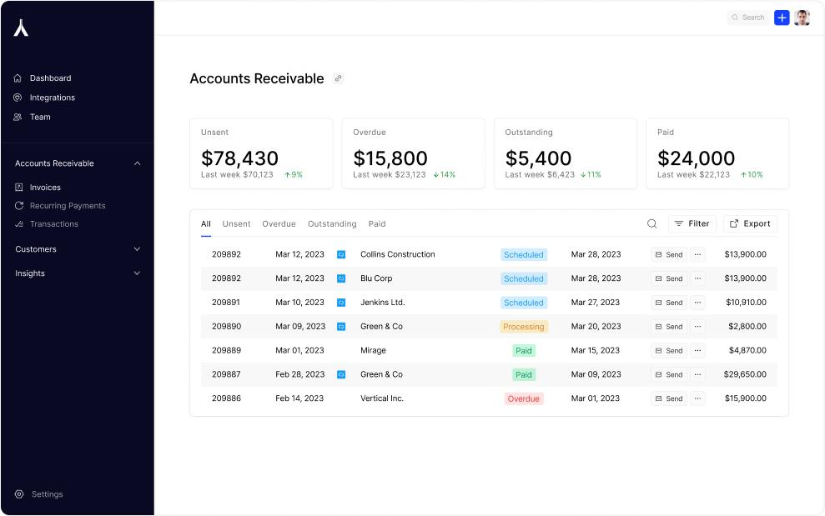
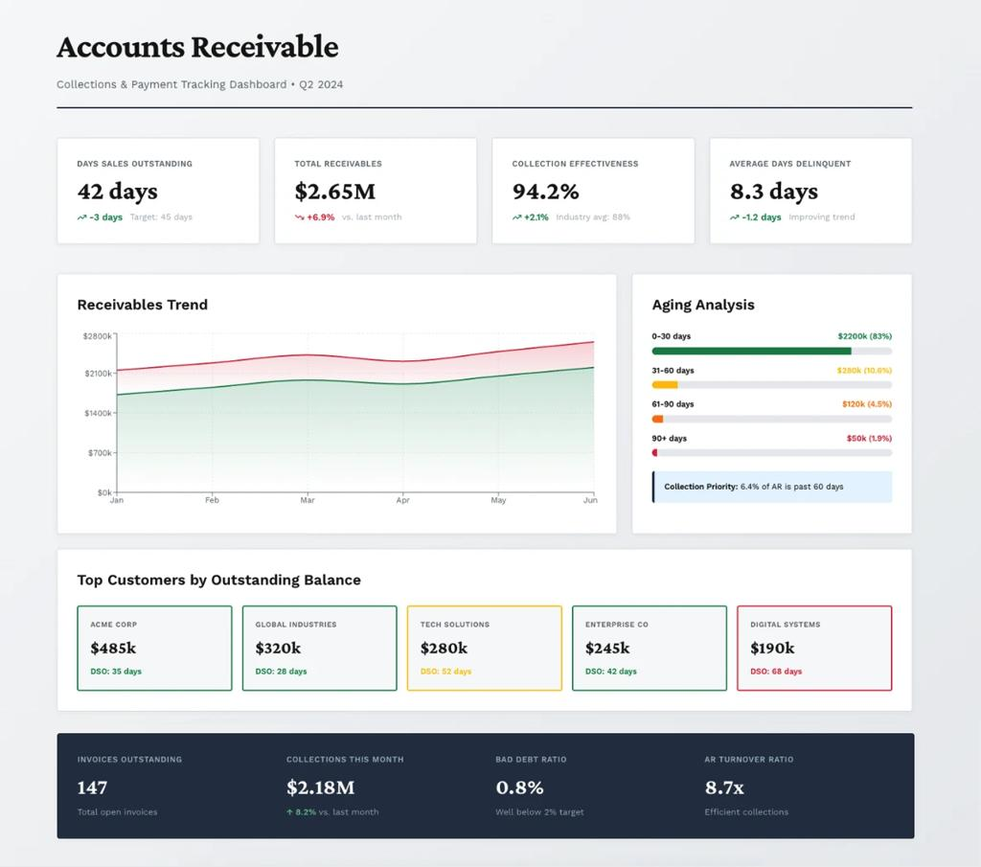
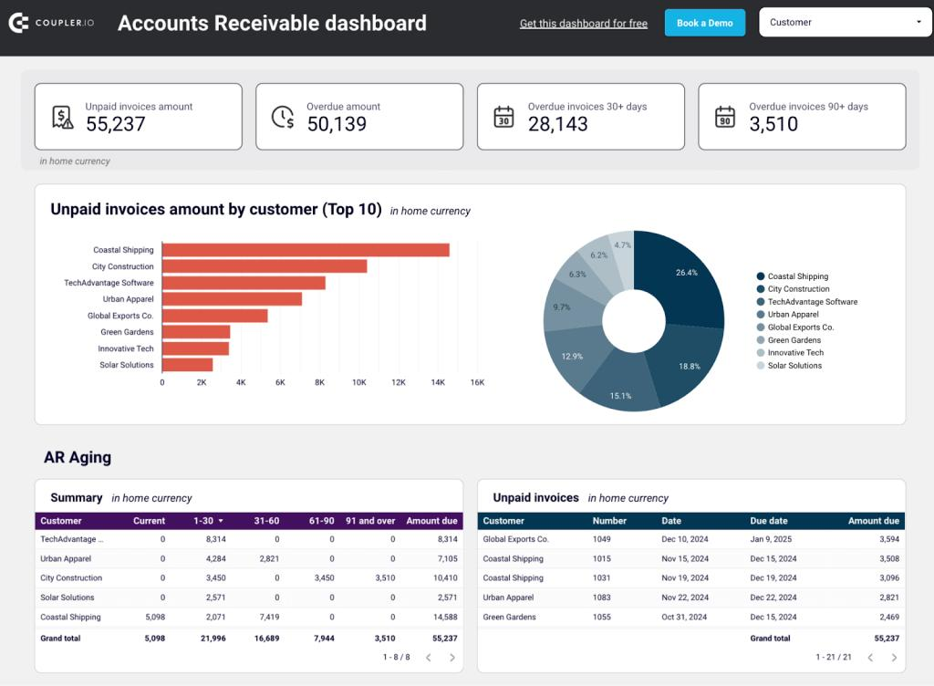
5

17. Inventory Pages
Product List
Columns:
- Product
- SKU
- Variant
- Buying Price
- Selling Price
- Stock
- Status

Stock Indicators
Use badges:
- In stock → Green
- Low stock → Orange
- Out of stock → Red

Product Form
Sections:
Basic Info
- Name
- Category
- Brand
Pricing
- Buying price
- Selling price
Inventory
- Stock
- Reorder level

18. Purchase Order Page
PO form:
Header:
- Supplier
- PO Number
- Dates
Body:
Items table
Footer:
Totals
Statuses shown clearly.

19. Expense Page
Form fields:
- Category
- Amount
- Date
- Description
- Receipt upload
Status badge:
- Pending
- Approved
- Rejected
Managers get approval buttons.

20. Refund Page
Refund review screen.
Layout:
Left:
Original invoice
Right:
Refund request
Show:
- Returned items
- Refund amount
- Reason
- Approval status
Buttons:
- Approve
- Reject
Use red warning accents.

21. Reports Page
Report center layout.
Top filters:
- Date range
- Report type
- Export type
Report cards:
- Sales
- Inventory
- Financial
- Staff
Charts + tables combined.
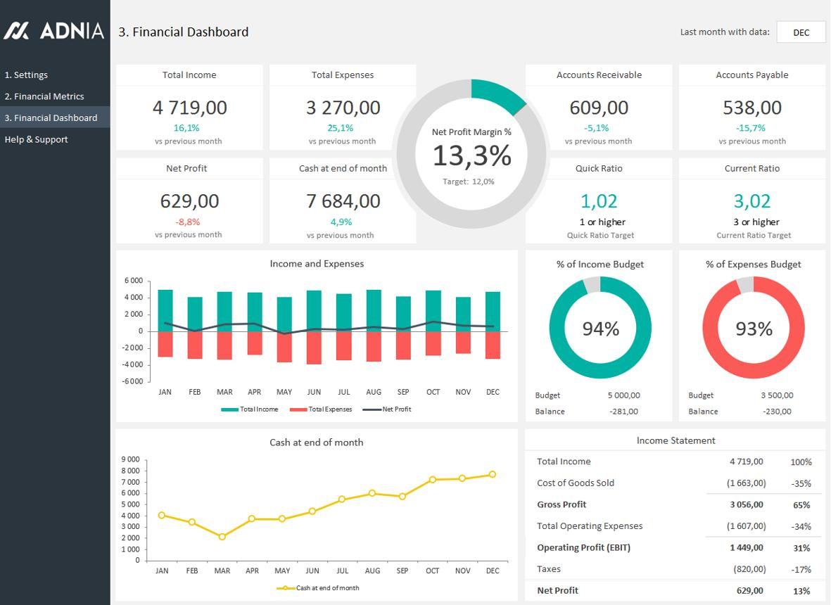
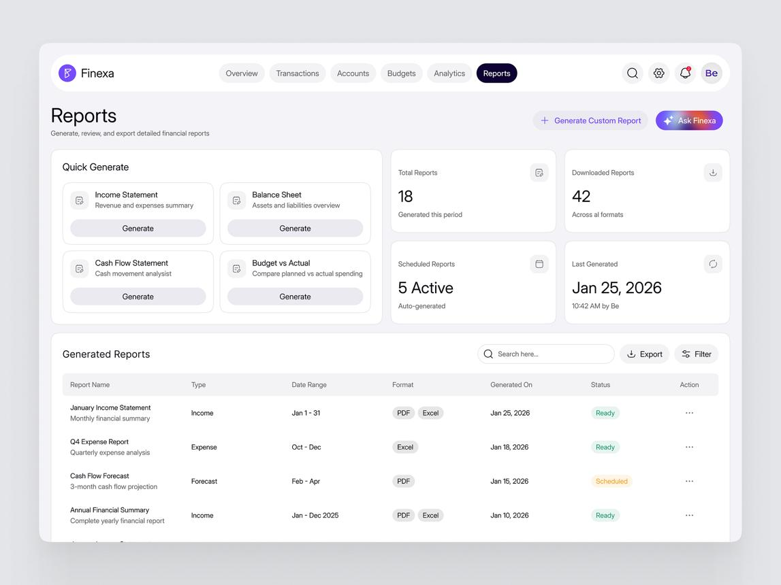
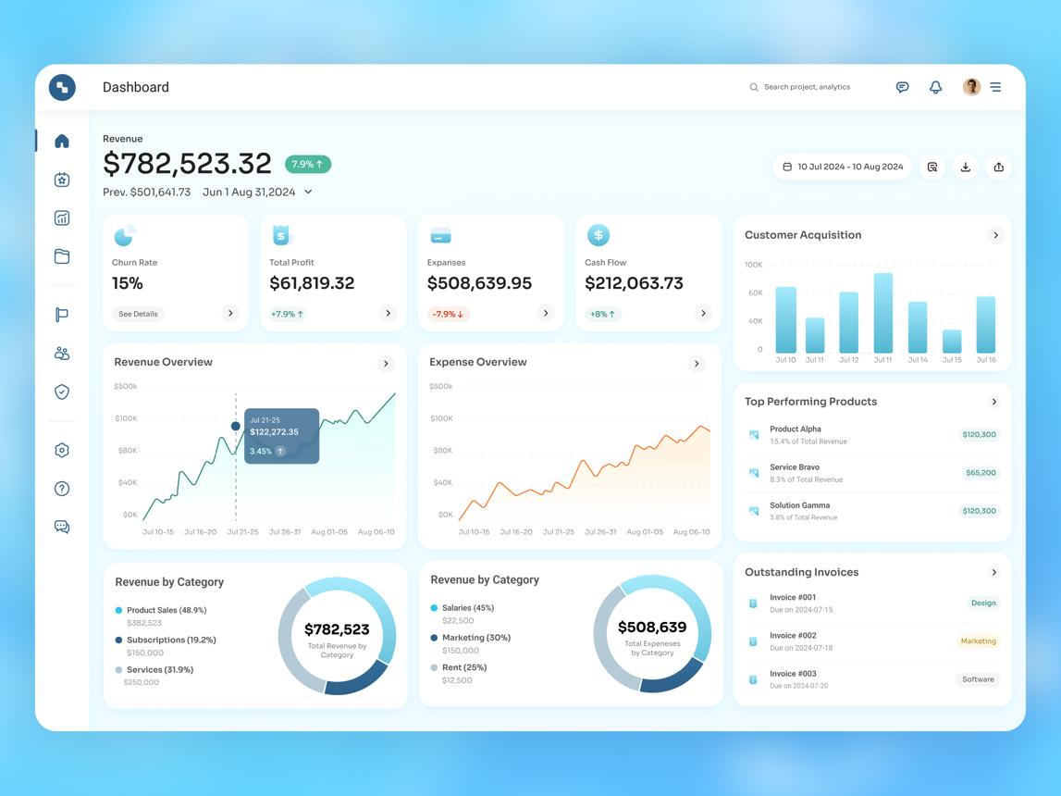
6

22. Staff Management Page
Table:
| Name | Role | Status | Last Login | Actions |
Actions:
- Edit
- Suspend
- Reset Password
- Permissions

23. Audit Logs Page
Advanced filter:
- User
- Action
- Date
- Entity
Table:
| User | Action | Entity | Time | IP |
Add:
View Details Modal
Shows:
Old value vs New value
Example:
{
"old": {"amount": 500000},
"new": {"amount": 450000}
}

24. Settings Page
Use tabbed layout.
Tabs:
- Business Profile
- Security
- Invoice
- Tax
- Notifications
- Payment Rules
- Integrations
- Backup

25. Backup Page
Cards:
- Last backup date
- Backup size
- Restore options
Buttons:
- Backup Now
- Download
- Restore
Restore action requires password.

26. Modal Standards
Use Bootstrap modals for:
- Confirm delete
- Approvals
- Quick edit
- Payment allocation
- Refund confirmation
Avoid page redirects for small actions.

27. Mobile Responsive Behavior
Critical because client wants phone access.
On mobile:
Sidebar becomes drawer.
Tables become:
- horizontal scroll
OR
- responsive cards
Priority mobile pages:
- Dashboard
- Sales
- Payments
- Debt tracking
Desktop-first, mobile-optimized.
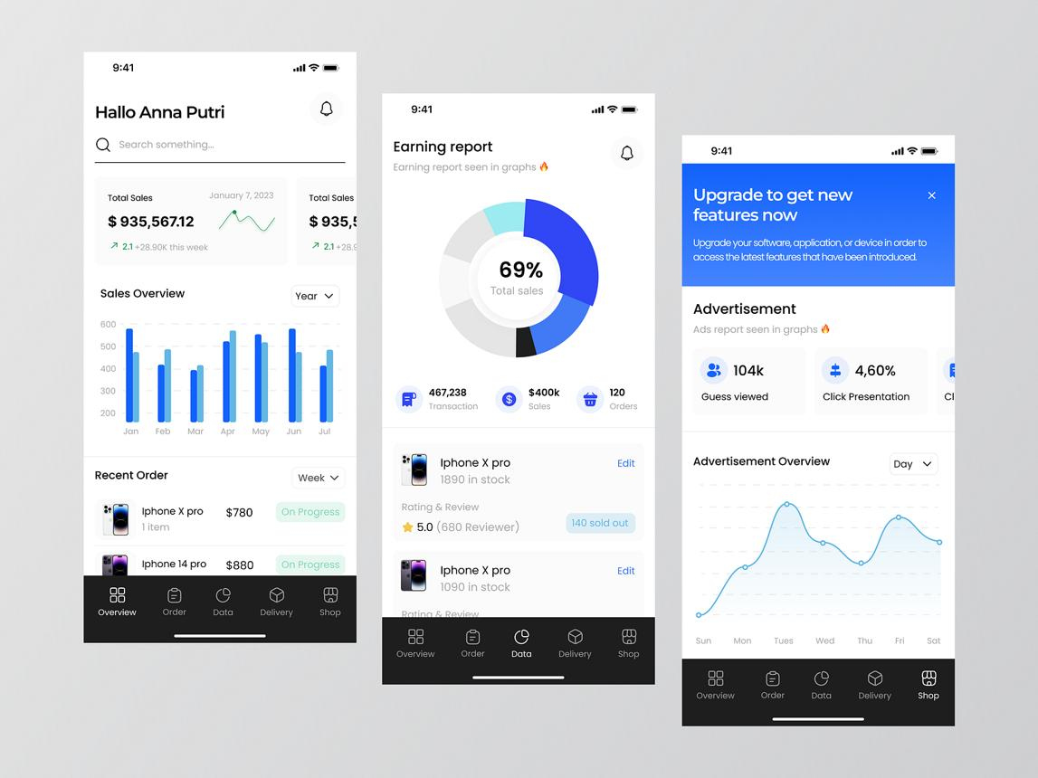
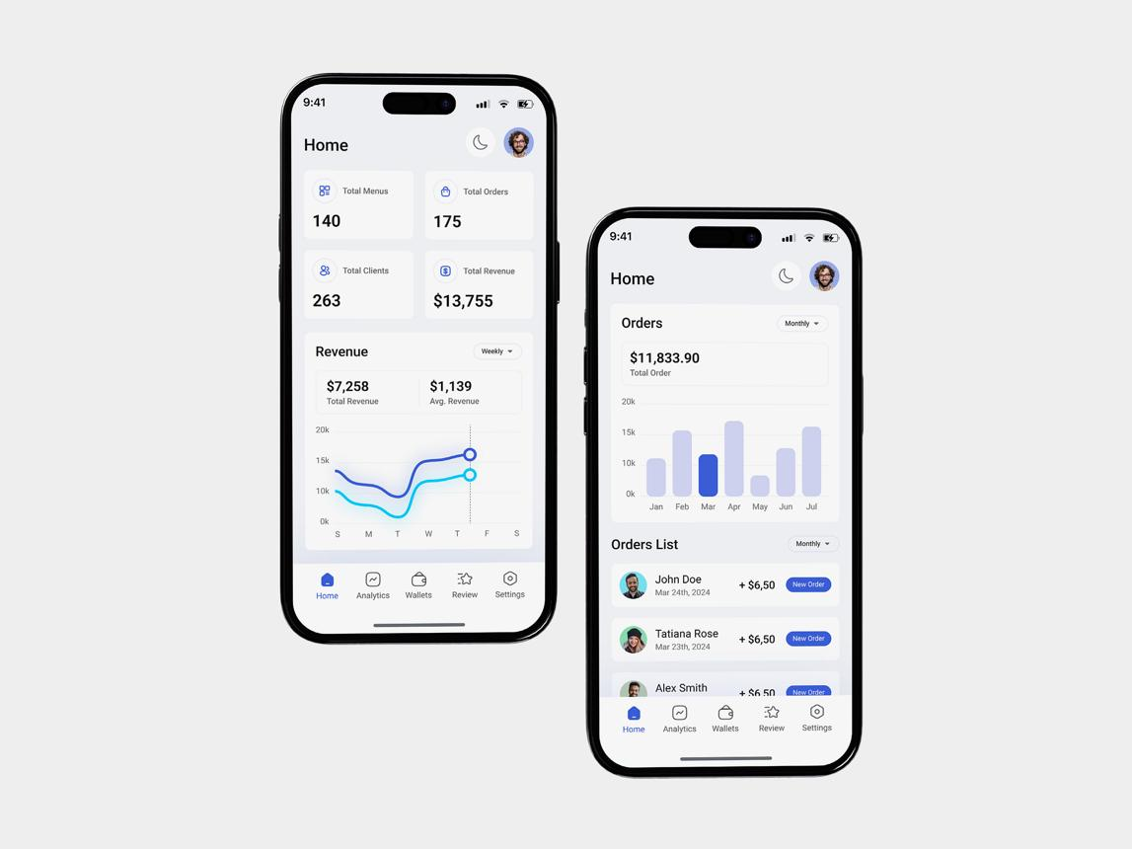
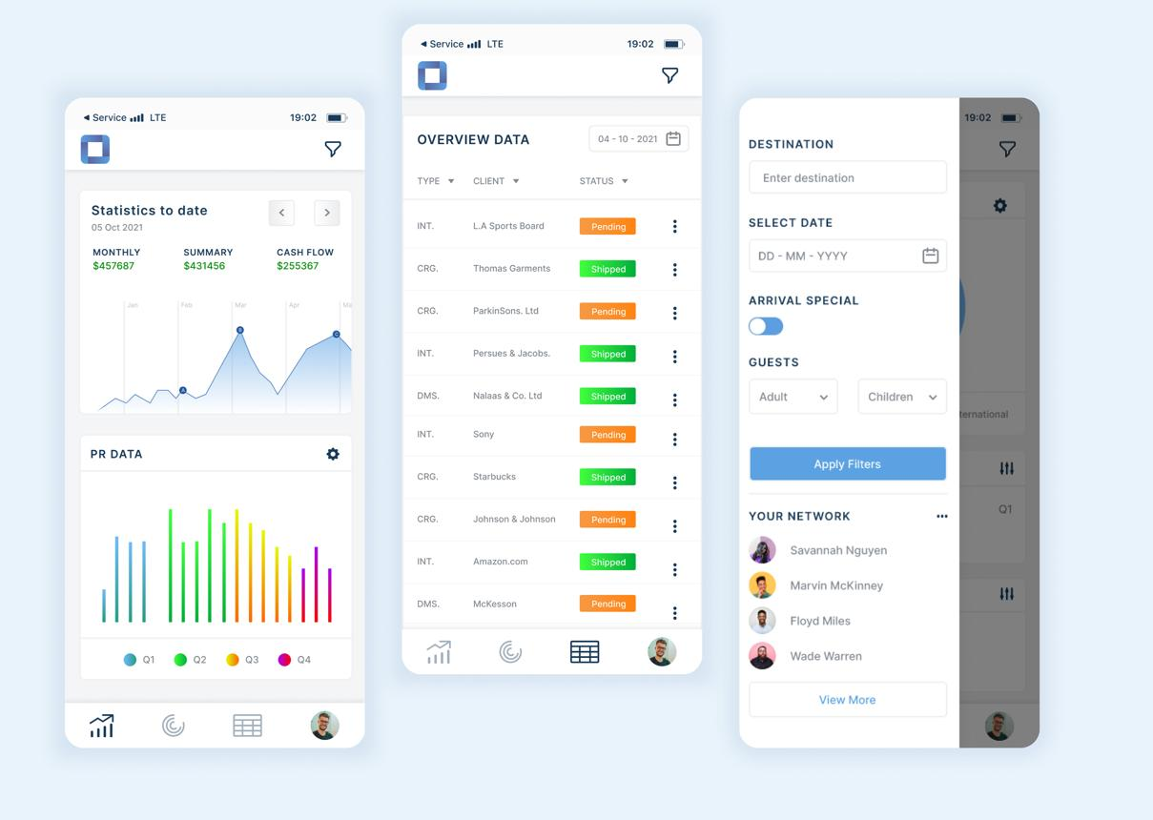
5

28. UX Rules (Important)
System UX rules:
Rule 1
Important actions require confirmation.
Example:
Void sale.

Rule 2
Success feedback visible.
Example:
Toast:
Payment recorded successfully.

Rule 3
Destructive actions are red.
Examples:
- Void
- Refund
- Delete

Rule 4
Financial numbers formatted.
Example:
UGX 1,250,000
Not:
1250000

Rule 5
Fast cashier workflow.
Target:
Complete sale in under 30 seconds.

29. Reusable Components
Build reusable components:
- KPI cards
- Tables
- Filters
- Badges
- Modals
- Charts
- Status chips
- Alerts
- Form controls
This speeds Laravel Blade development.

Senior UI/UX Engineer Assessment — Part 5
You now have the complete frontend blueprint:
✅ Navigation structure
✅ Screen architecture
✅ Page-by-page layouts
✅ Mobile behavior
✅ Design system
✅ UX rules
This gives your Laravel + Bootstrap developer a clear visual implementation path.

SRS Part 6 — Non-Functional Requirements
(Performance, Security, Scalability, Backup, Reliability)

1. Overview
This section defines technical expectations for:
- Performance
- Availability
- Security
- Reliability
- Scalability
- Maintainability
- Backup & Recovery
- Auditability
- Compatibility
- Monitoring
These standards ensure the system remains stable under production usage.

2. Performance Requirements
The system must feel fast for daily operations.
Because users include cashiers, delays directly affect business.

Response Time Targets
Target page load times:
Action | Maximum Time
Login | 3 sec
Dashboard load | 3 sec
Open sales page | 2 sec
Create invoice | 2 sec
Complete sale | 3 sec
Generate receipt PDF | 5 sec
Reports export | 10–30 sec
Goal:
95% of requests under 3 seconds

Database Query Performance
Queries must be optimized.
Avoid:
SELECT * FROM large_table
Use:
- Indexing
- Pagination
- Query optimization
- Eager loading in Laravel Eloquent ORM

Large Data Handling
For large datasets:
Use:
- Pagination
- Lazy loading
- Server-side filtering
Example:
Never load:
- 100,000 invoices at once
Load:
- 50–100 rows/page

3. Capacity Requirements
Expected Phase 1 capacity.

Daily Transactions
Expected:
- 100–1,000 sales/day
- 100–500 invoices/day
- 1–20 concurrent users

Data Growth
Expected yearly records:
Module | Annual Records
Sales | 100k+
Payments | 100k+
Audit Logs | 500k+
Stock Movements | 200k+
Database must support long-term growth.

4. Availability Requirements
System should support:
- Business hours mode
OR
- 24/7 operation
Client selected:
24/7 preferred
Target uptime:
99%+
Equivalent downtime:
~7 hours/month max

Downtime Types
Allowed:
- Planned maintenance
- Scheduled upgrades
Not acceptable:
- Random crashes
- DB corruption
- Data loss

5. Reliability Requirements
Financial systems must be reliable.
Transactions must not partially fail.
Example bad scenario:
Payment saved
BUT
invoice not updated
This causes accounting corruption.

Required Solution
Use DB transactions.
Example in Laravel Database Transactions:
DB::transaction(function () {
// save payment
// update invoice
// update ledger
});
Required for:
- Sales
- Payments
- Refunds
- Purchase receiving
- Debt waivers

6. Data Integrity Requirements
Critical.
System must prevent:
- Duplicate invoice numbers
- Negative stock
- Duplicate payments
- Broken references
- Invalid balances

Integrity Rules
Examples:
Rule 1
Invoice number unique.
Rule 2
SKU unique.
Rule 3
Overpayment forbidden.
Rule 4
Stock cannot go below zero (unless negative-stock override enabled by admin).
Rule 5
Payment allocation total must equal payment amount.
Example:
Payment = 500k
Allocations = 200k + 300k
Valid.

7. Security Requirements
This is a major section.
System contains:
- Financial records
- Customer data
- Staff accounts
- Payment history
Security must be strong.

Authentication Security
Requirements:
- Password hashing using bcrypt/Argon2
- Strong passwords
- Account lock after failed attempts
- Session timeout
- Remember-me token security
Use Laravel Authentication.

Password Policy
Minimum requirements:
- 8+ characters
- Uppercase
- Lowercase
- Number
- Special character
Example valid:
Sales@2026ERP

Session Security
Rules:
- Auto logout after inactivity
- Admin configurable timeout
- Session invalidation after password reset
Default timeout:
30 minutes

Authorization Security
RBAC enforced on server side.
Never rely only on UI hiding.
Bad:
hideButton()
Good:
Server validates permission.
Example:
Cashier sends manual POST request to refund endpoint.
Server must reject.

Encryption
Sensitive data should be encrypted.
Examples:
- API keys
- Backup credentials
- SMTP credentials
Store in:
Laravel Environment Configuration (.env)

Optional Security Features
Admin configurable:
- 2FA
- IP whitelist
- Login alerts
- Device restrictions

8. Web Security Requirements
Protect against common attacks.
Must prevent:

SQL Injection
Use:
- Prepared statements
- ORM
Laravel helps.

XSS
Sanitize user inputs.
Examples:
- Notes
- Comments
- Client names

CSRF
Enable CSRF tokens on forms.
Provided by Laravel CSRF Protection.

File Upload Security
For uploads:
- Receipts
- Product images
- Backup files
Validate:
- MIME type
- Size
- Extension
Disallow:
- PHP files
- Executables

9. Auditability Requirements
Every sensitive action must be traceable.
Must log:
- User
- Action
- Timestamp
- Old value
- New value
- IP
- Device
Audit log must be immutable.
Users cannot modify audit history.
Use:
spatie/laravel-activitylog

10. Scalability Requirements
Phase 1:
Single business
Phase 2:
SaaS multi-tenant
Architecture must scale.

Horizontal Growth Preparation
Design for future support of:
- Multiple businesses
- Branches
- More users
- Mobile apps
- APIs
Future additions:
tenant_id
branch_id
subscription_plan

Code Scalability
Architecture must be modular.
Recommended:
Controllers
Services
Repositories
Policies
Jobs
Events
Avoid fat controllers.

11. Hosting Constraints
Phase 1 hosting:
Namecheap Shared Hosting
Constraints:
- Limited CPU
- Limited RAM
- No Redis
- Limited queue support
Avoid:
- Heavy real-time features
- WebSockets
- Massive background workers
Prefer:
- Cron jobs
- Scheduled tasks
- Cache optimization

12. Backup Requirements
Critical for finance systems.

Automatic Backup
Frequency:
Daily mandatory
Recommended schedule:
- Database → daily
- Uploaded files → daily
- Full backup → weekly

Manual Backup
Super Admin can:
- Trigger backup
- Download backup

Backup Storage
Recommended:
Primary:
Server storage
Secondary:
Cloud backup
Examples:
- Google Drive
- Dropbox
- Amazon S3

Backup Retention
Recommended:
Backup Type | Retention
Daily | 30 days
Weekly | 3 months
Monthly | 1 year

13. Disaster Recovery Requirements
Need restore capability.

Recovery Targets
RPO (Recovery Point Objective)
Maximum data loss:
24 hours
Meaning:
At worst, lose less than 1 day.

RTO (Recovery Time Objective)
Maximum recovery time:
4 hours
Goal:
Restore business quickly.

Recovery Procedure
Steps:
Detect failure
→ isolate issue
→ restore backup
→ validate DB integrity
→ reopen system

14. Logging & Monitoring
System health should be observable.
Track:
- Errors
- Failed logins
- Slow queries
- Failed backups
- Payment failures
Use:
- Laravel logs
- Server logs
- Exception alerts
Log levels:
- Info
- Warning
- Error
- Critical

15. Browser Compatibility
Support:
- Google Chrome
- Mozilla Firefox
- Microsoft Edge
- Safari (basic support)
Minimum target:
Last 2 major versions

16. Device Compatibility
Must support:
- Desktop
- Laptop
- Tablet
- Mobile phone
Responsive layout mandatory.
Critical mobile modules:
- Dashboard
- Sales
- Payments
- Debt tracking

17. Maintainability Requirements
Code must be maintainable.
Standards:
- PSR coding standards
- Clean naming
- Reusable components
- Modular services
- Documentation
Required documentation:
- Setup guide
- Deployment guide
- Backup guide
- API docs (future)

18. Testing Requirements
Required testing types.

Unit Testing
Test:
- Calculations
- Services
- Helpers
Use Laravel Testing.

Integration Testing
Test:
- Sale flow
- Payment flow
- Refund flow

UAT
Client verifies:
- Reports
- Invoices
- Workflows

19. Notification Reliability
Notifications should retry on failure.
Channels:
- SMS
- Email
- WhatsApp
- In-app
Rules:
- Log delivery status
- Retry failed sends
- Avoid duplicate sends

20. Future Readiness Requirements
System should support future modules without rewrite.
Future modules:
- SaaS billing
- Branch management
- Mobile app
- Public API
- AI analytics
- Predictive stock management
Architecture should allow extension.

Senior Systems Engineer Assessment — Part 6
This section defines the technical quality bar.
You now have:
✅ Performance requirements
✅ Security standards
✅ Backup & recovery
✅ Scalability plan
✅ Reliability guarantees
✅ Maintainability rules
At this point, your SRS is about 95% complete.

SRS Part 7 — API / Backend Architecture + Laravel Folder Structure
This section defines:
- Backend architecture pattern
- API design
- Laravel folder structure
- Service layer strategy
- Repository pattern
- Middleware
- Events & jobs
- Validation strategy
- Error handling
This determines whether your codebase stays maintainable after 6–24 months.

1. Architectural Style
I recommend:
Modular Monolith Architecture
Not microservices yet.
Why?
Phase 1 deployment is:
- Single business
- Shared hosting
- 1–20 concurrent users
Microservices would add unnecessary complexity.
Use:
Modular Monolith + Service Layer + Repository Pattern
Benefits:
- Easier deployment
- Easier debugging
- Faster development
- SaaS-ready later

2. Backend Layers
Architecture layers:
Request
↓
Route
↓
Middleware
↓
Controller
↓
Service
↓
Repository
↓
Model
↓
Database
Each layer has a responsibility.

3. Layer Responsibilities

Routes Layer
Purpose:
Map URLs to controllers.
Example:
Route::resource('clients', ClientController::class);
Route::post('/sales/checkout', [SaleController::class, 'checkout']);
Files:
routes/
web.php
api.php

Middleware Layer
Purpose:
Security and access control.
Examples:
- auth
- role
- permission
- session timeout
- IP restriction
Custom middleware examples:
CheckPermission
CheckSubscription (future SaaS)
CheckBusinessHours
Laravel middleware docs: Laravel Middleware

Controller Layer
Purpose:
Receive request and return response.
Controllers should be thin.
Bad:
SaleController = 1500 lines
Good:
Controller only:
- validate request
- call service
- return response
Example:
public function store(StoreSaleRequest $request)
{
$sale = $this->saleService->createSale($request->validated());
return redirect()->route('sales.show', $sale);
}

Service Layer
Critical for this ERP.
Purpose:
Contains business logic.
Examples:
- Sales workflow
- Payment allocation
- Debt calculations
- Stock adjustments
- Profit calculations
Example services:
SaleService
InvoiceService
PaymentService
LedgerService
InventoryService
ExpenseService
RefundService
ReportService
Why important?
Because your system has complex workflows:
Example sale:
Create invoice
→ create sale
→ reduce stock
→ create payment
→ update debt
→ update ledger
→ audit log
Never put this inside controllers.

Repository Layer
Purpose:
Database access abstraction.
Example:
Instead of:
Invoice::where(...)
inside services repeatedly.
Use:
$invoiceRepository->findOverdueInvoices();
Repositories:
ClientRepository
InvoiceRepository
PaymentRepository
ProductRepository
Useful for:
- cleaner code
- testing
- future API scaling

Model Layer
Use Eloquent models.
Examples:
User
Role
Client
Invoice
Payment
Sale
Product
Variant
Supplier
Expense
Refund
Eloquent docs: Laravel Eloquent

4. Recommended Laravel Folder Structure
I recommend custom enterprise structure.
app/
├── Console/
├── Events/
├── Exceptions/
├── Helpers/
├── Http/
│ ├── Controllers/
│ ├── Middleware/
│ ├── Requests/
├── Jobs/
├── Listeners/
├── Mail/
├── Models/
├── Notifications/
├── Observers/
├── Policies/
├── Repositories/
├── Services/
├── Traits/
└── Utils/
This is much better than default-only structure.

5. Controller Structure
Organize by modules.
app/Http/Controllers/
├── Auth/
├── Dashboard/
├── Client/
├── Inventory/
├── Sales/
├── Accounting/
├── Admin/
Examples:
ClientController
InvoiceController
SaleController
PaymentController
ExpenseController
ReportController

6. Request Validation Structure
Use Form Requests.
Do NOT validate inside controllers.
Example:
app/Http/Requests/
├── Client/
├── Sales/
├── Inventory/
Examples:
StoreClientRequest
StoreSaleRequest
StorePaymentRequest
Validation example:
public function rules()
{
return [
'client_id' => 'required|exists:clients,id',
'amount' => 'required|numeric|min:1'
];
}
Laravel validation docs: Laravel Validation

7. Service Layer Structure
Recommended:
app/Services/
├── Auth/
├── Sales/
├── Inventory/
├── Finance/
├── Reports/
Detailed services:
SaleService
InvoiceService
QuotationService
PaymentService
DebtService
LedgerService
ProductService
StockService
PurchaseOrderService
ExpenseService
RefundService
NotificationService
AuditService
BackupService
ReportService

8. Repository Structure
app/Repositories/
├── ClientRepository.php
├── ProductRepository.php
├── InvoiceRepository.php
├── PaymentRepository.php
├── ExpenseRepository.php
Pattern:
interface ClientRepositoryInterface
class ClientRepository
Optional but recommended.

9. Database Transaction Strategy
Critical for finance modules.
Must wrap in transactions.
Examples:

Sale Creation Transaction
Start transaction
→ create invoice
→ create sale
→ update stock
→ create ledger entries
→ commit
If error:
rollback
Use:
Laravel Database Transactions
Example:
DB::transaction(function () {
// business operations
});

10. Event-Driven Architecture (Recommended)
Useful for decoupling.
Examples:
Events:
SaleCreated
PaymentReceived
RefundApproved
ExpenseApproved
LowStockDetected
Listeners:
SendReceipt
UpdateDashboardMetrics
CreateAuditLog
NotifyManager
Architecture:
Event
→ Listener 1
→ Listener 2
→ Listener 3
Laravel events: Laravel Events

11. Jobs / Queues
Use for slow tasks.
Examples:
- Send email
- Generate reports
- Backup
- Export CSV/PDF
- Notifications
Structure:
app/Jobs/
├── SendInvoiceEmailJob
├── GenerateReportJob
├── BackupDatabaseJob
Since shared hosting:
Avoid heavy queue workers.
Prefer:
- scheduled jobs
- cron execution
Laravel queues: Laravel Queues

12. Scheduled Tasks
Use Laravel scheduler.
Examples:
Daily:
- backup
- debt reminders
- low stock scan
Weekly:
- summary reports
Monthly:
- cleanup logs
- archive reports
Scheduler docs: Laravel Task Scheduling
Example:
Schedule::command('backup:run')->daily();

13. Notification Architecture
Channels:
- In-app
- Email
- SMS
- WhatsApp Business
Structure:
app/Notifications/
├── PaymentReceivedNotification
├── LowStockNotification
├── DebtReminderNotification
Triggers:
- overdue invoice
- payment success
- stock alert

14. Policies / Authorization
Use Laravel policies.
Do not hardcode permissions everywhere.
Example:
public function refund(User $user, Sale $sale)
{
return $user->hasPermission('approve_refund');
}
Structure:
app/Policies/
├── SalePolicy
├── InvoicePolicy
├── RefundPolicy
Policies docs: Laravel Authorization Policies

15. Exception Handling
Centralized error handling.
Custom exceptions:
InsufficientStockException
OverpaymentException
UnauthorizedRefundException
InvalidPaymentAllocationException
Folder:
app/Exceptions/
Example:
throw new InsufficientStockException();

16. API Architecture (Future Mobile App Ready)
Even if Phase 1 uses Blade views, design APIs early.
API versioning:
/api/v1/
Example endpoints:

Auth
POST /api/v1/login
POST /api/v1/logout

Clients
GET /api/v1/clients
POST /api/v1/clients

Sales
POST /api/v1/sales
GET /api/v1/sales

Payments
POST /api/v1/payments

Reports
GET /api/v1/reports/sales
Response example:
{
"success": true,
"message": "Payment recorded",
"data": {}
}
API responses should be standardized.

17. Caching Strategy
Cache expensive data.
Examples:
Cache:
- dashboard KPIs
- settings
- permissions
- low stock summaries
Since shared hosting:
Use:
- file cache
OR
- database cache
Avoid Redis initially.
Caching docs: Laravel Cache

18. Logging Strategy
Log channels:
- app logs
- error logs
- audit logs
- security logs
Examples:
Payment failure
Permission violation
Backup failure
Use:
Laravel Logging

19. Testing Architecture
Testing folders:
tests/
├── Feature/
├── Unit/
Unit tests:
- calculation helpers
- services
Feature tests:
- sales workflow
- payment workflow
- refund workflow
Testing docs: Laravel Testing

20. Deployment Structure
Shared hosting deployment:
public_html/
index.php
storage/
bootstrap/cache/
Need:
- .env
- cache optimization
- route caching
- config caching
Commands:
php artisan config:cache
php artisan route:cache
php artisan view:cache

21. Coding Standards
Required standards:
- PSR-12
- SOLID principles
- DRY
- KISS
Naming conventions:
Good:
calculateOutstandingBalance()
Bad:
calcBal()

Senior Backend Architect Assessment — Part 7
You now have a production-grade backend blueprint.
This defines:
✅ Architecture pattern
✅ Laravel structure
✅ Service layer
✅ API strategy
✅ Event system
✅ Security middleware
✅ Deployment model
At this point, the SRS is ~99% complete.
Only one final deliverable remains:

MASTER AI-CODER PROMPT — Build Full ERP / POS / Debt Management SaaS System
1. Role & Mission
Act as a senior software architect, senior Laravel engineer, senior MySQL database engineer, senior UI/UX engineer, and security engineer with 15+ years of experience.
Your task is to build a production-grade ERP / POS / Sales / Inventory / Debt Management SaaS-ready web application for a Uganda-based business.
The system must be:
- Clean architecture
- Secure
- Scalable
- Maintainable
- Financially accurate
- Mobile responsive
This is not a prototype. Build production-quality code.

2. Tech Stack (Mandatory)
Frontend:
- HTML5
- CSS3
- JavaScript (Vanilla or lightweight utility JS)
- Bootstrap 5
- Bootstrap Icons
- Blade templates
Backend:
- Laravel 12 (or latest stable compatible)
- PHP 8.3+
Database:
- MySQL
Server:
- Shared hosting compatible (Namecheap phase 1)
Do NOT use:
- Node backend
- React
- Vue
- Heavy SPA architecture
- Redis dependency
- Docker requirement
Reason:
Must run on shared hosting.

3. Architecture Requirements
Use:
Modular Monolith + Service Layer + Repository Pattern + RBAC
Request flow:
Route
→ Middleware
→ Controller
→ Service
→ Repository
→ Model
→ Database
Rules:
- Thin controllers
- Fat services
- Repositories for DB access
- Use transactions for financial operations
- Modular folder organization

4. Required Laravel Folder Structure
app/
├── Console/
├── Events/
├── Exceptions/
├── Helpers/
├── Http/
│ ├── Controllers/
│ ├── Middleware/
│ ├── Requests/
├── Jobs/
├── Listeners/
├── Mail/
├── Models/
├── Notifications/
├── Policies/
├── Repositories/
├── Services/
├── Traits/
└── Utils/
Controllers organized by modules:
Controllers/
├── Auth
├── Dashboard
├── Sales
├── Inventory
├── Finance
├── Admin

5. Core Business Overview
The business sells:
- Physical products
- Services
Supports:
- Sales
- Quotations
- Invoices
- Payments
- Debts
- Inventory
- Expenses
- Refunds
- Reports
Single business in Phase 1.
Must be SaaS-ready for Phase 2.
Future SaaS support:
- Tenants
- Subscriptions
- Plan management
- Multi-company isolation

6. User Roles
Roles:
- Super Admin
- Manager
- Supervisor
- Cashier
RBAC must be configurable from settings.
Permission examples:
Permission | Super Admin | Manager | Supervisor | Cashier
Create Sale | Yes | Yes | Yes | Yes
Edit Sale | Yes | Yes | Limited | No
Delete Sale | Yes | Limited | No | No
Approve Refund | Yes | Yes | No | No
Manage Staff | Yes | Limited | No | No
Settings | Yes | Limited | No | No
Reports | Full | Medium | Limited | Own only
All permissions must be enforced server-side.

7. Required Modules
Build all modules.

Authentication Module
Features:
- Login
- Logout
- Forgot password
- Password reset
- Session timeout
- Strong password enforcement
- Optional 2FA setting
- Login audit logs

Dashboard Module
Show KPI cards:
- Today sales
- Monthly revenue
- Outstanding debt
- Profit
- Expenses
- Low stock
- Active staff
- Refund alerts
Charts:
- Revenue trend
- Sales by category
- Debt collection
- Top products
Activity feed included.

Staff Management Module
Super Admin controls staff.
Features:
- Add user
- Edit user
- Deactivate
- Reset password
- Assign roles
- Permission overrides
- View login history

Client Module
Features:
- Create client
- Edit client
- Client profile
- Client ledger
- Purchase history
- Outstanding debt
- Notes
Fields:
- Client code
- Name
- Phone
- Email
- Address
- Credit limit
- Status

Product Module
Features:
- Product CRUD
- Category CRUD
- Brand CRUD
- Variant support
- SKU
- Barcode
- Stock tracking
Product variants example:
T-shirt:
- Small
- Medium
- Large
Phone:
- 64GB
- 128GB
Fields:
- Product name
- SKU
- Barcode
- Buying price
- Selling price
- Stock quantity
- Reorder level

Inventory Module
Features:
- Auto stock deduction after sale
- Purchase stock increment
- Manual adjustments
- Stock movement logs
- Low stock alerts
- Out-of-stock alerts
Stock statuses:
- In stock
- Low stock
- Out of stock
Prevent negative stock unless override enabled.

Service Module
Supports services.
Examples:
- Consultation
- Installation
- Repair
Services:
- Belong to category
- Can have default price
- Allow custom invoice price

Supplier Module
Features:
- Supplier CRUD
- Supplier ledger
- Outstanding payable
- Supplier history
Fields:
- Supplier name
- Contact
- Address
- Products supplied
- Outstanding balance

Purchase Order Module
Features:
- Create PO
- Approve PO
- Receive stock
- Partial receiving
- Cancel PO
Statuses:
- Draft
- Approved
- Ordered
- Partial Received
- Received
- Cancelled

Quotation Module
Features:
- Create quotation
- Send quotation
- Print quotation
- PDF quotation
- Convert to invoice
Statuses:
- Draft
- Sent
- Approved
- Rejected
- Expired
- Converted
Rules:
- Expiry date required
- Cannot edit after sending
- One-click convert to invoice

Invoice Module
Features:
- Create invoice
- Tax calculations
- Discounts
- Print invoice
- PDF invoice
- Thermal print support
- WhatsApp sending optional
Invoice statuses:
- Draft
- Unpaid
- Partial
- Paid
- Overdue
- Cancelled
- Voided
Invoice supports:
- Multiple products/services
- Due dates
- Notes
Invoice totals:
Subtotal = Sum(items)
VAT = 18%
Total = Subtotal + VAT - Discount
Balance = Total - Paid
Currency:
UGX only.
Format:
UGX 1,250,000

Sales Module
Workflow:
Client arrives
→ Staff creates sale
→ Invoice generated
→ Payment received (full/partial)
→ Debt created if balance remains
→ Stock reduced
→ Ledger updated
→ Audit logged
Features:
- POS-style interface
- Fast checkout
- Barcode support
- Receipt printing
- Draft sale
- Sale history
Target:
Complete sale < 30 sec

Payment Module
Features:
- Full payment
- Partial payment
- Installments
- Multi-invoice payment allocation
Rules:
- No overpayment
- Exact or less only
- Can pay several invoices at once
Allocation modes:
- FIFO (oldest first)
- Manual
- Split
Payment methods:
- Cash
- Bank
- Mobile Money
- Cheque
- Other
Maintain payment ledger.

Debt Management Module
Track all receivables.
Debt statuses:
- Paid
- Partial
- Unpaid
- Overdue
- Waived
Color indicators:
- Green = Fully paid
- Orange = Partial
- Red = Unpaid
Rules:
- Due dates required
- Debt waiver allowed
- No interest
Must show:
- Total outstanding
- Overdue debts
- Collection rate
Client ledger mandatory.
Clarification:
This tracks how much customer owes business, not vice versa.

Expense Module
Required for profit calculations.
Formula:
Profit = Revenue - Expenses - Cost of Goods Sold
Expense categories:
- Rent
- Salaries
- Fuel
- Internet
- Electricity
- Purchases
- Tax payments
Features:
- Expense CRUD
- Receipt upload
- Approval workflow
All roles can add expenses.
Approval based on permissions.

Refund / Return Module
Features:
- Product return
- Service refund
- Invoice reversal
- Credit note
Rules:
Refund may:
- Reverse stock
- Reverse VAT
- Adjust ledger
Workflow:
Sale 500k
Return 100k
Refund processed
Balances updated
Refund statuses:
- Pending
- Approved
- Rejected
Approval required.

Reports Module
Required reports:
Sales:
- Daily
- Weekly
- Monthly
Debt:
- Outstanding
- Overdue
- Collection rate
Staff:
- Best salesperson
- Sales per staff
Accounting:
- Revenue
- Profit
- Expenses
Inventory:
- Low stock
- Fast moving
- Dead stock
Export:
- CSV
- PDF
- Excel

Notifications Module
Channels:
- In-app
- SMS
- Email
- WhatsApp
Notifications:
- Debt overdue reminders
- Low stock alerts
- Payment received
- Refund alerts
Retry failed notifications.

Audit Log Module
Track everything.
Must log:
- Login
- Logout
- Sale creation
- Payment changes
- Debt edits
- Staff creation
- Refund approvals
Audit log fields:
- User
- Action
- Timestamp
- Old values
- New values
- IP
- Device
Audit logs immutable.

Backup Module
Features:
- Daily backup
- Manual backup
- Restore backup
- Download backup
Retention:
- Daily: 30 days
- Weekly: 3 months
- Monthly: 1 year
Recovery targets:
- RPO: 24h
- RTO: 4h

Settings Module
Tabs:
- Business profile
- Invoice settings
- Security
- Tax
- Notifications
- Payment rules
- Backup
- Business hours
- 2FA
- IP restrictions
Admin configurable settings.

8. Database Requirements
Use normalized relational schema.
Main tables include:
- users
- roles
- permissions
- clients
- customer_ledgers
- categories
- brands
- products
- product_variants
- stock_movements
- services
- suppliers
- supplier_ledgers
- purchase_orders
- purchase_order_items
- quotations
- quotation_items
- invoices
- invoice_items
- sales
- payments
- payment_allocations
- debts
- debt_waivers
- expense_categories
- expenses
- refunds
- refund_items
- audit_logs
- notifications
- settings
- backups
Requirements:
- foreign keys
- indexes
- soft deletes
- timestamps
Use migrations and seeders.

9. UI/UX Requirements
Frontend:
Responsive Bootstrap admin dashboard.
Layout:
- Top navbar
- Sidebar
- Main content
- Responsive mobile drawer
Pages:
- Login
- Dashboard
- Clients
- Sales POS
- Inventory
- Quotations
- Invoices
- Payments
- Debts
- Expenses
- Refunds
- Reports
- Staff
- Audit logs
- Settings
- Backup
UI rules:
- Financial clarity
- Fast workflows
- Minimal clicks
- Mobile-friendly
Use colors:
- Green = paid
- Orange = partial
- Red = debt/refund warning

10. API Requirements
Create API-ready architecture.
Versioning:
/api/v1/
Endpoints:
- auth
- clients
- sales
- invoices
- payments
- reports
Use JSON responses:
{
"success": true,
"message": "Operation successful",
"data": {}
}
Prepare for mobile app integration later.

11. Non-Functional Requirements
Performance:
- 95% requests < 3 sec
Capacity:
- 100–1000 sales/day
- 1–20 concurrent users
Availability:
- 24/7 preferred
- 99% uptime
Scalability:
- SaaS-ready
- tenant-ready
Maintainability:
- Clean architecture
- Modular code
- Documentation

12. Security Requirements
Mandatory protections:
- bcrypt/Argon password hashing
- RBAC authorization
- CSRF protection
- XSS prevention
- SQL injection prevention
- File upload validation
- Session timeout
- Optional 2FA
- Audit logs
Password policy:
- 8+ chars
- uppercase
- lowercase
- number
- special char

13. Engineering Standards
Follow:
- PSR-12
- SOLID
- DRY
- KISS
Coding rules:
- Clean naming
- Reusable components
- No giant controllers
- No duplicated logic
Use:
- Laravel Policies
- Form Requests
- Service classes
- Repository pattern
- Events
- Listeners
- Scheduled jobs

14. Required Services
Create services:
SaleService
InvoiceService
QuotationService
PaymentService
DebtService
LedgerService
ProductService
StockService
PurchaseOrderService
ExpenseService
RefundService
NotificationService
AuditService
BackupService
ReportService

15. Critical Financial Rule
Use DB transactions for all financial workflows.
Example:
Start Transaction
→ Create Sale
→ Create Invoice
→ Deduct Stock
→ Record Payment
→ Update Ledger
→ Create Debt
→ Audit Log
Commit
Rollback on failure.
No partial writes allowed.

16. Deliverables Required From AI Coder
Generate complete production-ready project including:
Backend
- Laravel project
- Models
- Controllers
- Services
- Repositories
- Migrations
- Seeders
- Middleware
- Policies
Frontend
- Blade views
- Bootstrap components
- Responsive dashboard
- Forms
- Tables
- Charts
Business Logic
- Payment allocation
- Debt calculations
- Inventory automation
- Reports
- Notifications
Security
- Authentication
- Authorization
- Validation
- Audit logging
Deployment
Include:
- Installation guide
- .env.example
- Setup commands
- Shared hosting deployment guide

Final Instruction to AI Coder
Do NOT skip modules.
Do NOT simplify business logic.
Do NOT replace architecture with shortcuts.
Do NOT use fake placeholder logic for financial calculations.
Build this as a real enterprise-grade ERP/POS system with clean, scalable code and production-ready architecture.

Senior Systems Engineer Final Assessment
You now have a complete enterprise SRS package:
✅ Part 1 — Project Scope
✅ Part 2 — Functional Modules
✅ Part 3 — Roles & Workflows
✅ Part 4 — Database Schema
✅ Part 5 — UI/UX Blueprint
✅ Part 6 — Non-functional Requirements
✅ Part 7 — Backend Architecture
✅ Part 8 — Master Build Prompt
This is easily 90–150 pages worth of professional system documentation if formatted into a formal PDF.

